中華民國齒顎矯正部定專科醫師甄審口試病例審查格式
(Case Assessment Form for the Oral Test of Board Exam of the Taiwan Board of Orthodontists)
115年修訂版 (Revision 20260909)
治療前病例屬性定義 (Definitions for Case Category prior treatment)：
1. 以 Angle Classification 為標準 (All the cases are categorized by the Angle Classification)。
2. Class I ---- 上顎第一大臼齒的近心頰側咬頭的三角隆線必須咬在下顎第一大臼齒的近心頰側溝上 2 mm(<2mm 不含2mm)咬合者 ( The triangular ridge of the mesiobuccal cusp of upper 1st molar bites within 2 mm (not include) on the mesiobuccal groove of lower 1st molar)。
3. Class II --- 上顎第一大臼齒的近心頰側咬頭的三角隆線咬在下顎第一大臼齒的近心頰側溝近心 2 mm（含）以上咬合者 (The triangular ridge of the mesiobuccal cusp of upper 1st molar bites at least 2 mm mesial to the mesiobuccal groove of lower 1st molar)。
4. Class III --- 上顎第一大臼齒的近心頰側咬頭的三角隆線咬在下顎第一大臼齒的近心頰側溝遠心2 mm（含）以上咬合者 ( The triangular ridge of the mesiobuccal cusp of upper 1st molar bites at least 2 mm distal to the mesiobuccal groove of lower 1st molar)。

必備病例屬性 (Category for the required cases)：
_____a. Complete two-stage treatment case: starting with mixed dentition stage
The progressive records to show the termination of the first stage treatment and initiation of the second stage
treatment are required.
_____b. Class I malocclusion with bimaxillary protrusion, non-surgical case
The Class I molar relationship should present in both sides of dentition. The treatment modality should not
combine with the orthognathic surgery.
_____c. Class I malocclusion case: including open-bite, deep-bite or severe space deficiency
The Class I molar relationship should present in both sides of dentition. The definition of open bite: open contact or negative overbite in the front teeth. The definition of deep bite: more than 50% of the vertical overlap in the front teeth. The amount of space deficiency should exceed 5 mm in either maxillary or mandibular arch.
_____d. Class II div. 1 malocclusion with space deficiency
The Class II molar relationship should appear at least one side of the dentition with maxillary anterior proclination or space deficiency (more than 5 mm in either arch). The overjet should exceed 3 mm.
_____e. Class II div. 1 malocclusion case: high mandibular plane angle and ant. open bite
The Class II molar relationship should appear at least one side of the dentition. The high mandibular plane angle could be either briefly determined by the extension line of mandibular plane, which locates inside the occipital bone in the lateral cephalogram; or by measuring the SN-MP >34.48 ˚ in women / 35.05 ˚ in men (15-30 y/o) ; SN-MP >37.01 ˚ in girl / 36.97 ˚ in boy (10-14y/o).
_____ f. Class II div. 2 case
The Class II molar relationship should appear at least one side of the dentition. At least 2 retroclined maxillary central incisors should be required with increased overbite (>50%) in the front teeth.
_____g. Anterior cross-bite malocclusion: complete cross-bite of more than three incisors (either upper or lower)
Complete anterior cross bite of more than 3 incisors are required.
____h. Severe maxilla-mandible basal bone discrepancy: either sagittal or vertical or transverse
Sagittal discrepancy: either one or both sides of the molar relationship could be Class II or Class III.
Vertical discrepancy: either excess or deficiency in the lower anterior facial height.
Transverse discrepancy: the chin deviation relative to facial midline should exceed 4 mm.
_____i. Adult malocclusion with multidisciplinary treatment
Cases needs orthodontic treatment and other multilevel care(s), including implantology, prosthodontics, cosmetic dentistry, periodontology, TMD or sleep disorder. Surgical orthodontics only is excluded. Presentation of both orthodontic treatment and multilevel care(s) is mandatory.

自選病例診斷(Optional Case): ______
考生須由上述九類病例屬性中選擇三例（不得重覆）加上二例任何自選病例（自選病例種類不受限於上述之九類病例屬性）

合併五例；其中必須包括至少含三例有拔牙或缺牙之治療病例，且該拔牙或缺牙空間必須關閉。合併正顎手術治療之病例至多兩例。
(The applicant has to prepare 5 cases, including 3 cases selected from the different items in the category for the required cases, and 2 case of optional case on his/her preference. However, these 5 cases should include at least 3 cases of tooth extraction due to orthodontic purposes or of edentulous space, and the extraction space or edentulous space must be closed. The numbers of cases which combined with orthognathic surgeries should be limited within two. The category of the optional case could be out of the range in the 9 selected items.)

申請者代號 (Applicant assigned #):____________ (秘書處填寫 to be assigned)

 | 治療前之紀錄  (Pretreatment Records) | 治療中之記錄 (Progress treatment Record) | 治療後之紀錄  (Post-treatment Records)
紀錄日期 (Date of Record) | 2018.07.27 | 2019.06.26 | 2020.07.14
年齡 (Age) | 25Y5M | 27Y5M | 27Y5M
紀錄項目 (Items of Record)：
牙科模型 (Dental Model) | V |  | V
側面測顱X光 (Lateral Cephalogram) | V |  | V
環口X光 (Panoramic Radiograph) | V |  | V
口內外照片(Intra& Extra-oral Photos) | V | v | V
其他 (others) | V (optional) | V (optional) | V (optional)
指定病例屬性(Required Case Category)：
h. Severe maxilla-mandible basal bone discrepancy: vertical
自選病例診斷(Diagnosis for Optional case)：__________________

病患資料 (Patient Information)
開始治療年齡 (Age commencing treatment)：25Y6M
性別 (Gender)：Female
治療前之紀錄 (Pretreatment Records) 紀錄日期 (Date of Record)： ____________________
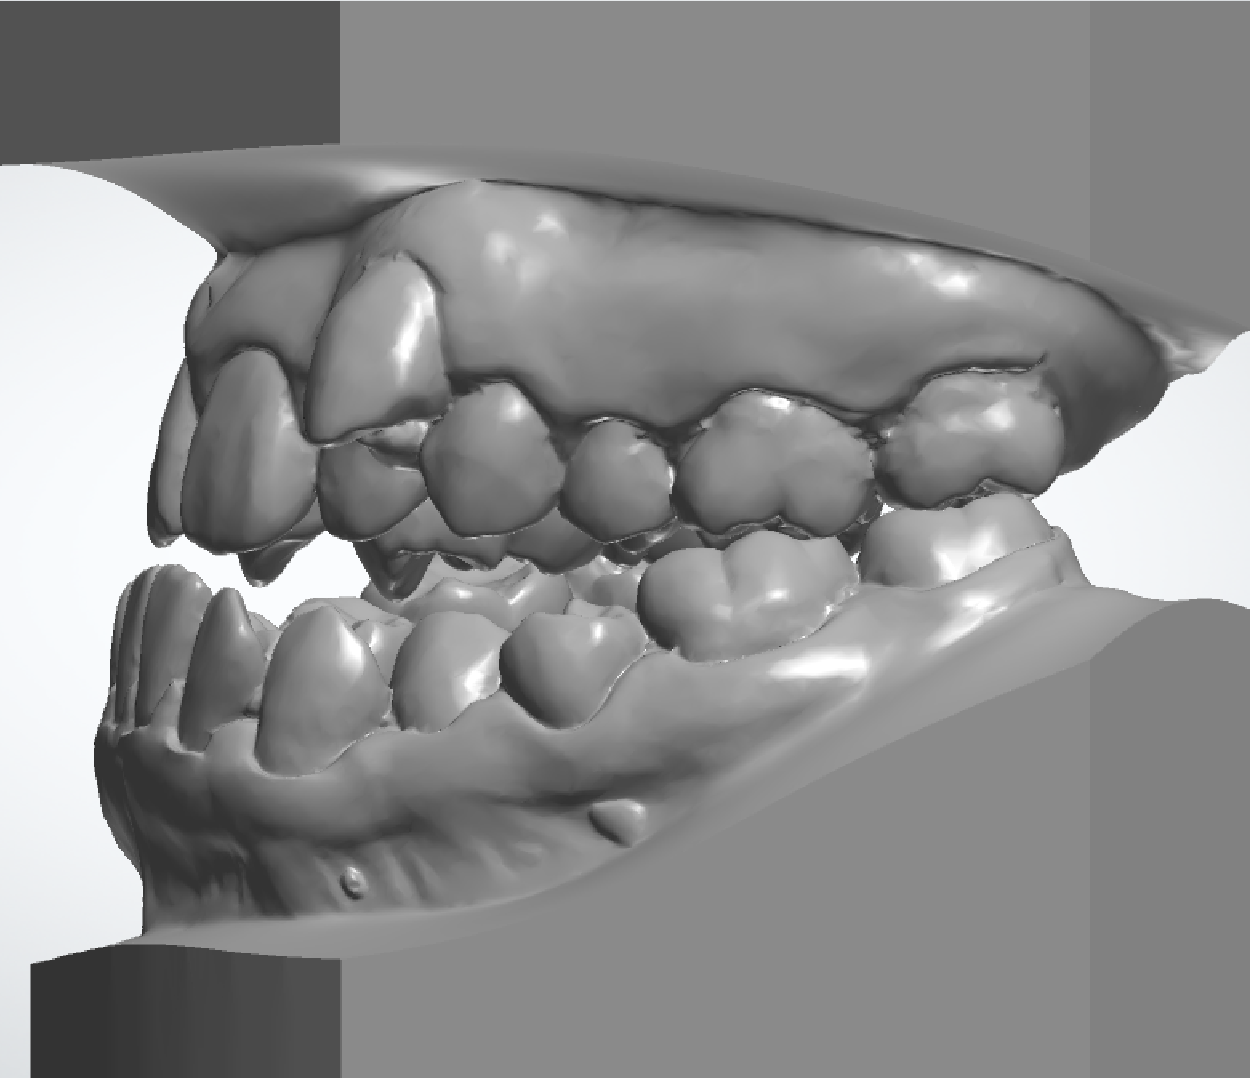
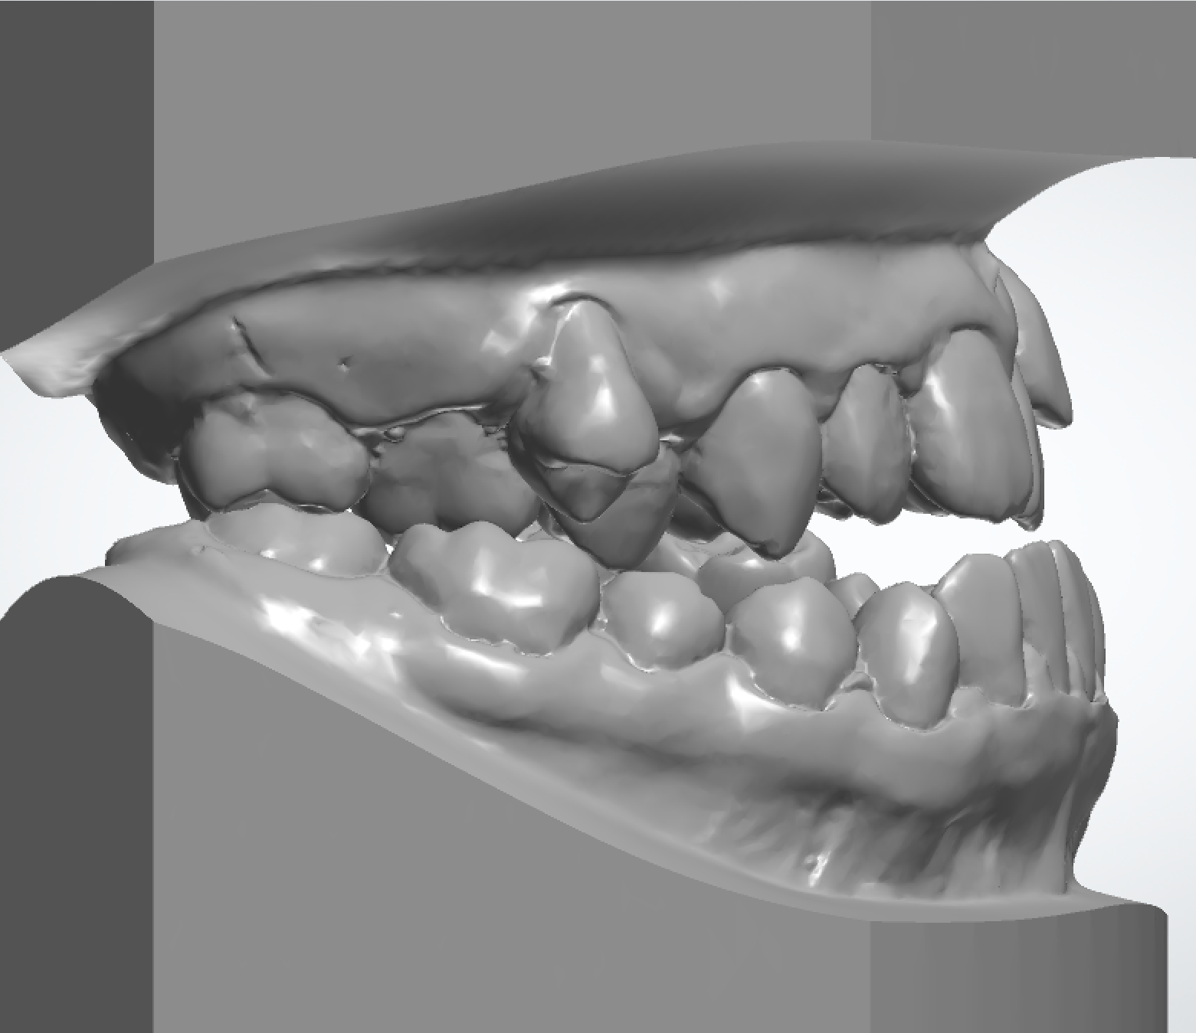

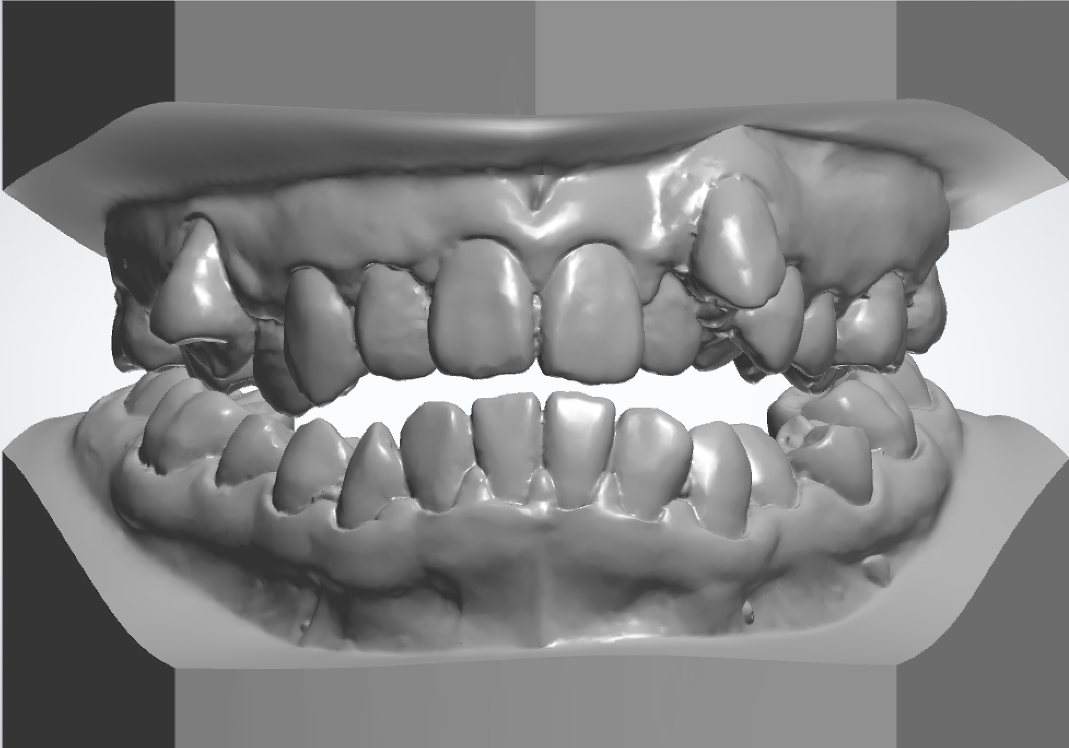
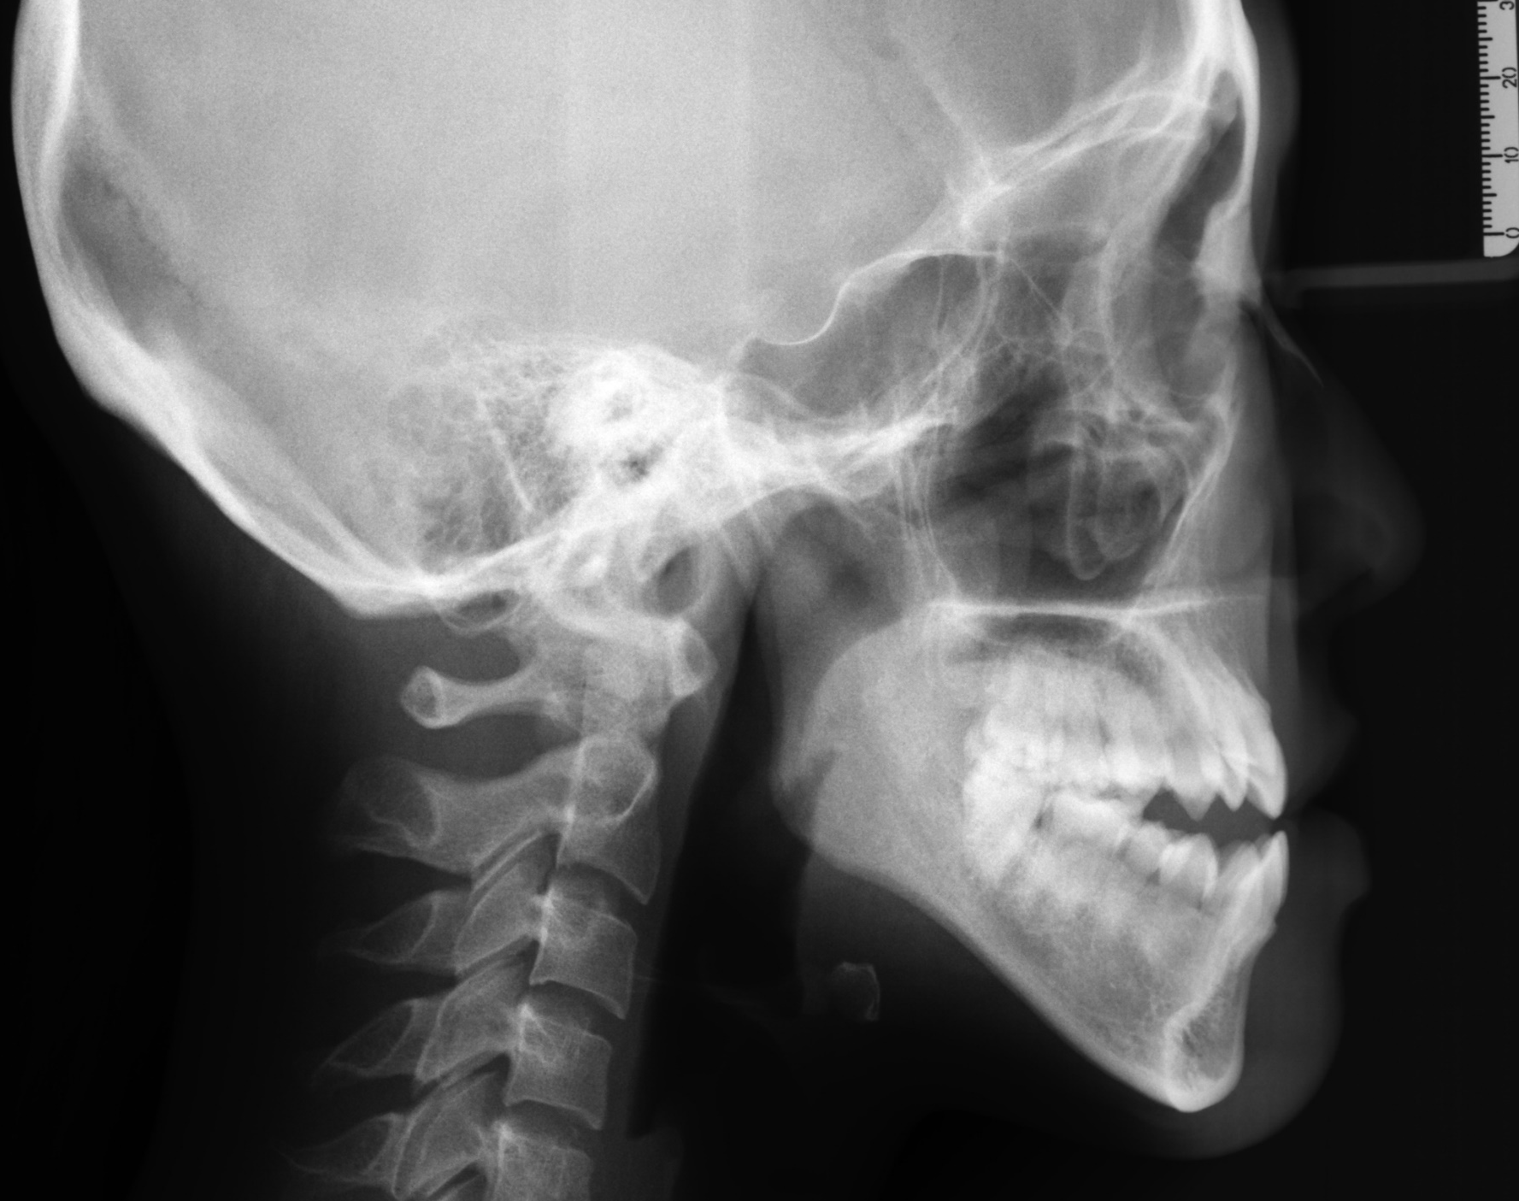

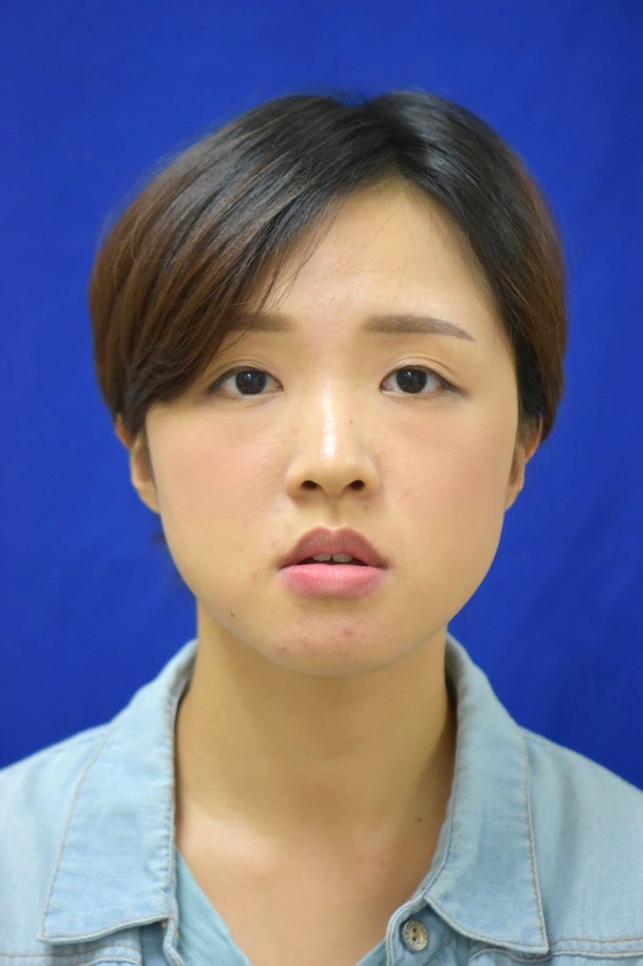
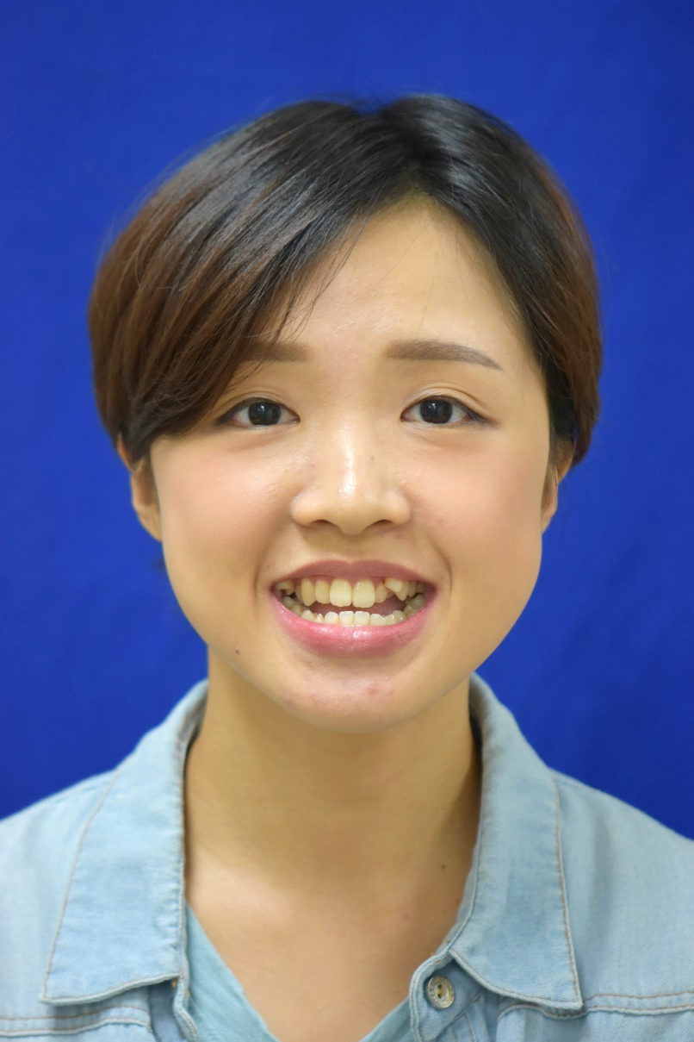
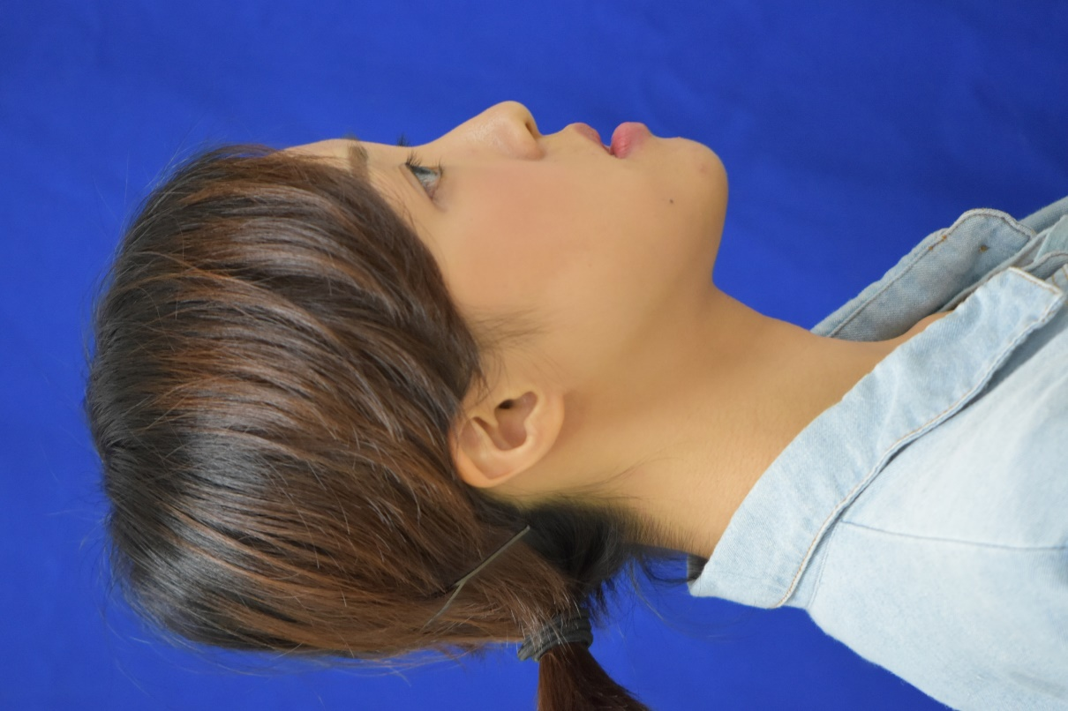
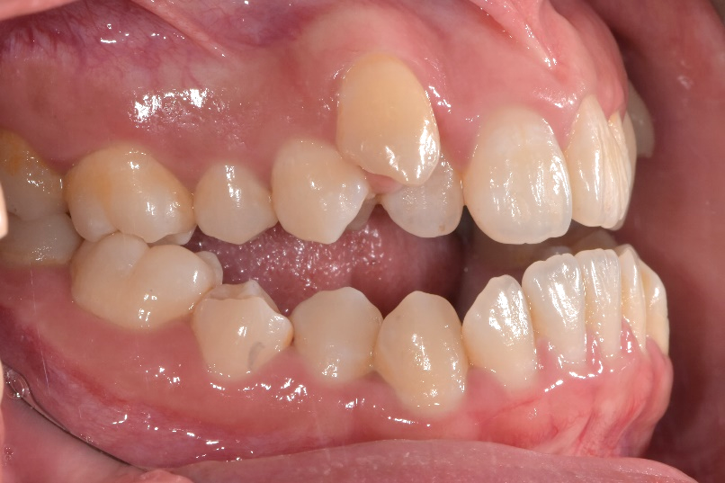
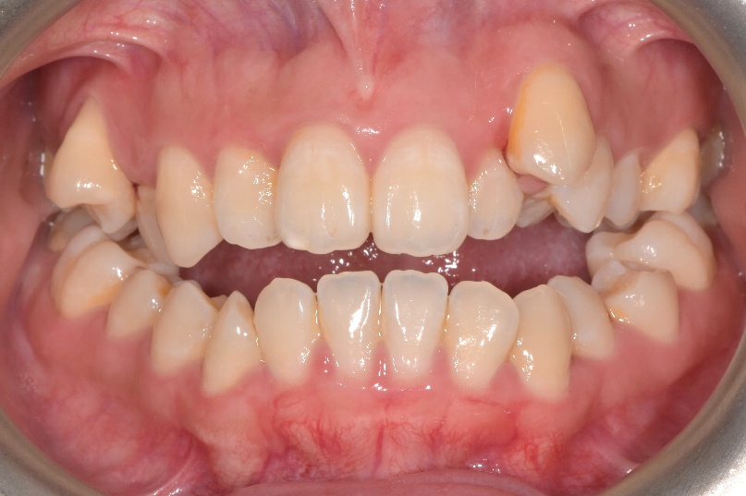
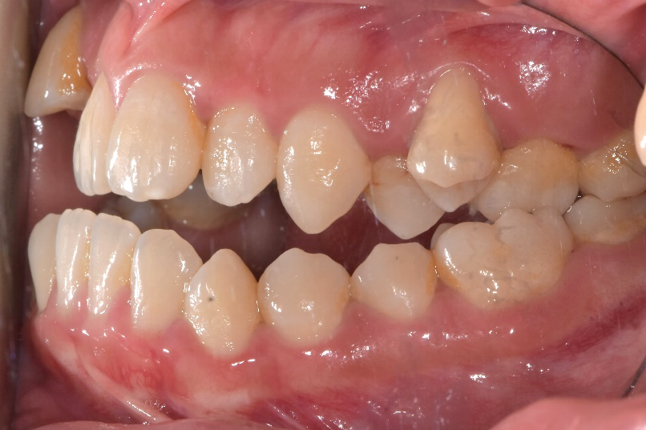
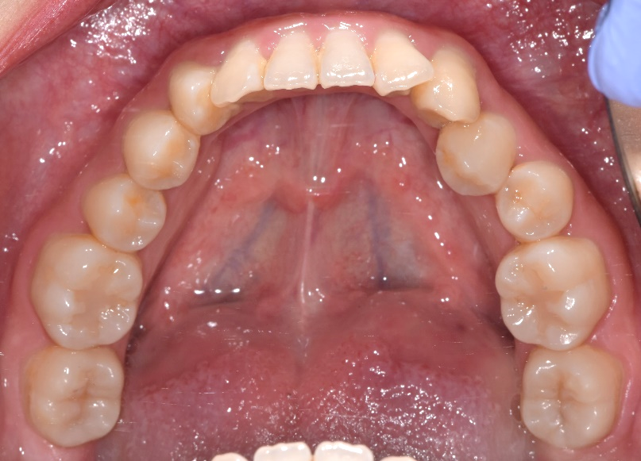
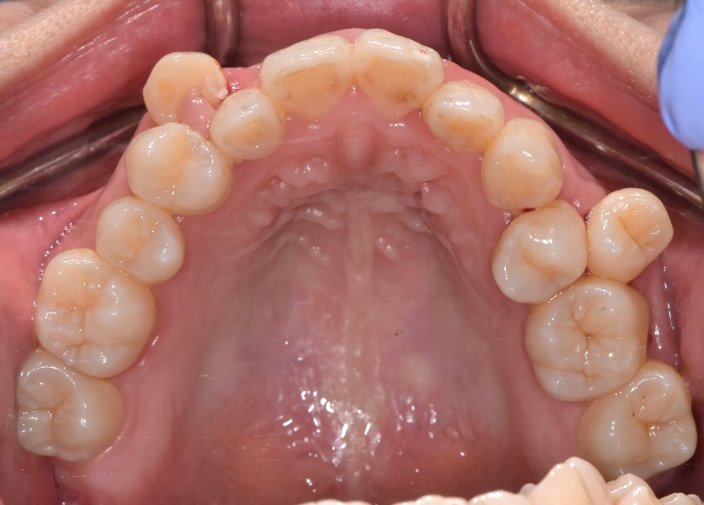
治療前之口內外照片 (Pre-treatment Intra- & Extra-oral Photos) —
治療前之口內外照片
Date: 2018.07.27
Age: 25Y5M

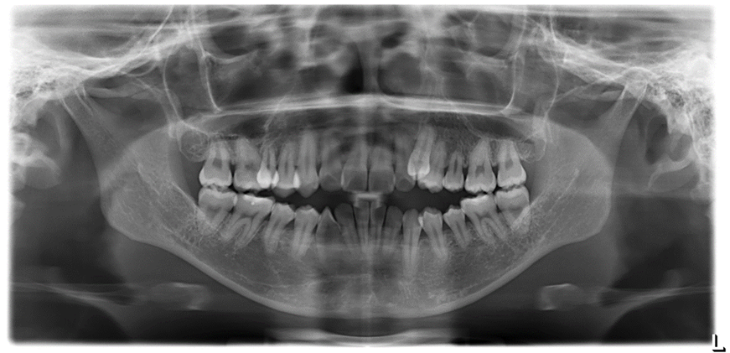

治療前之模型照片
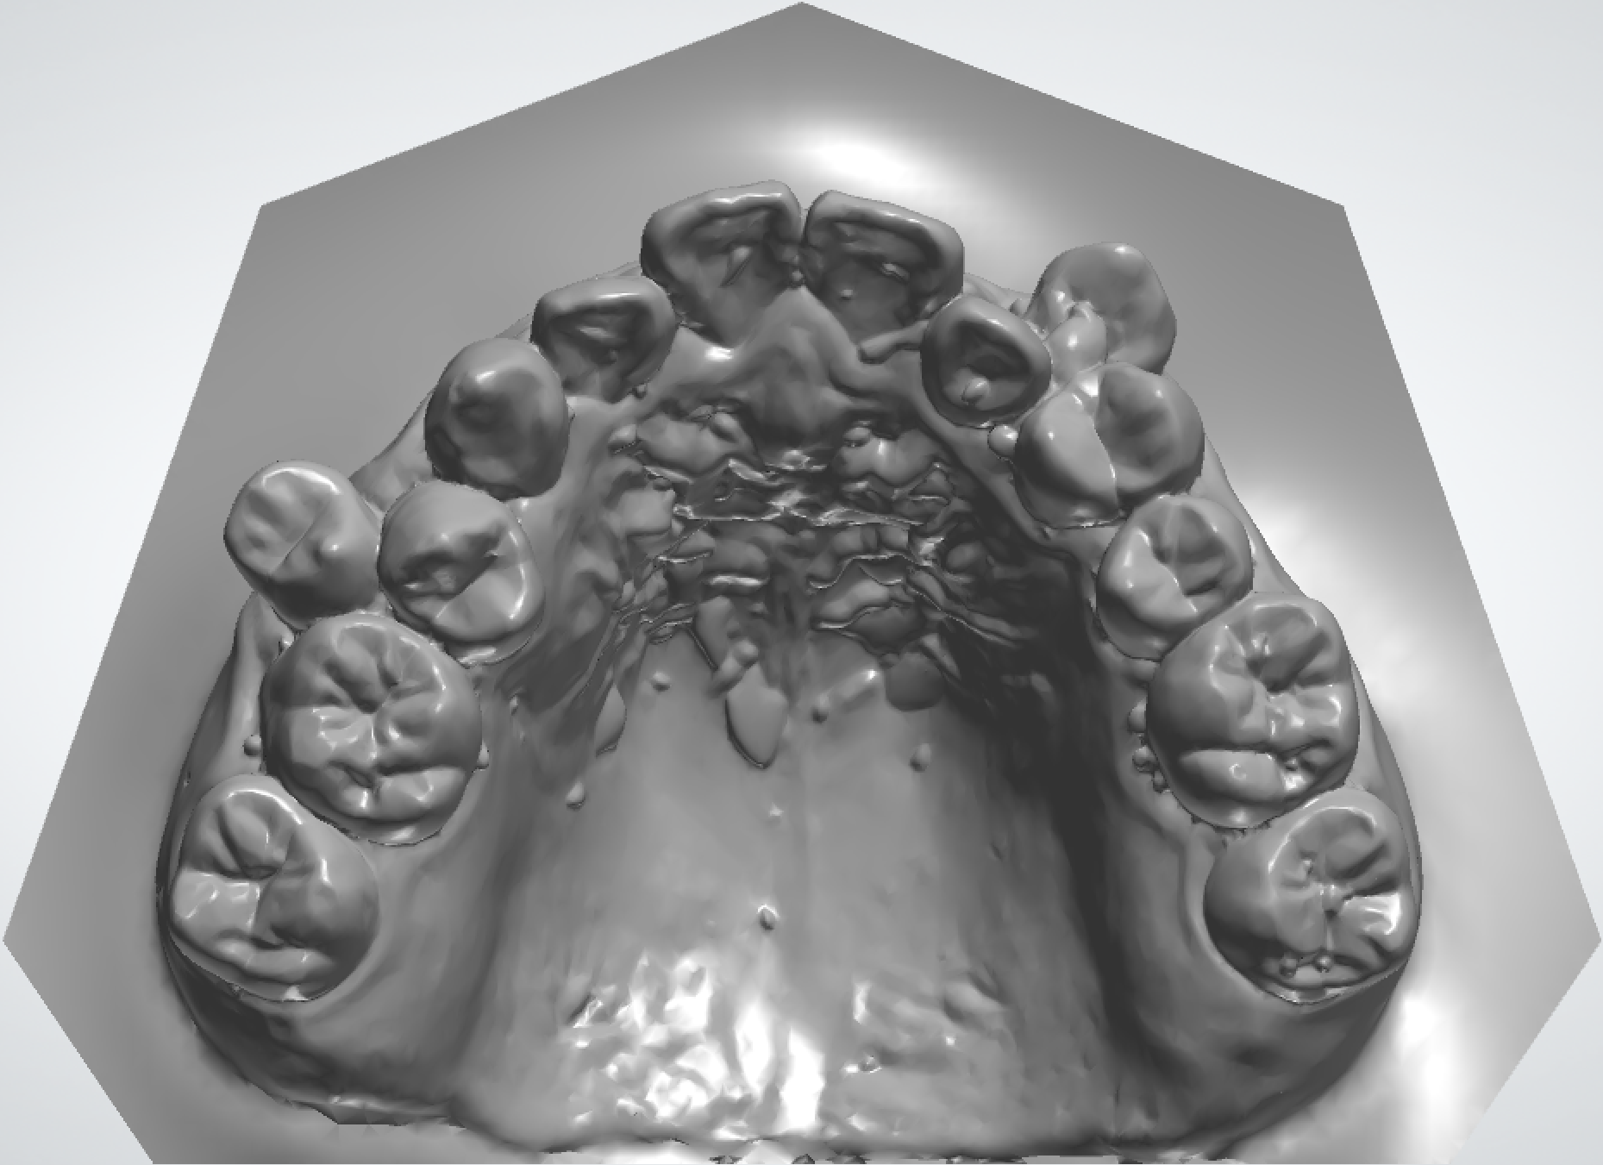
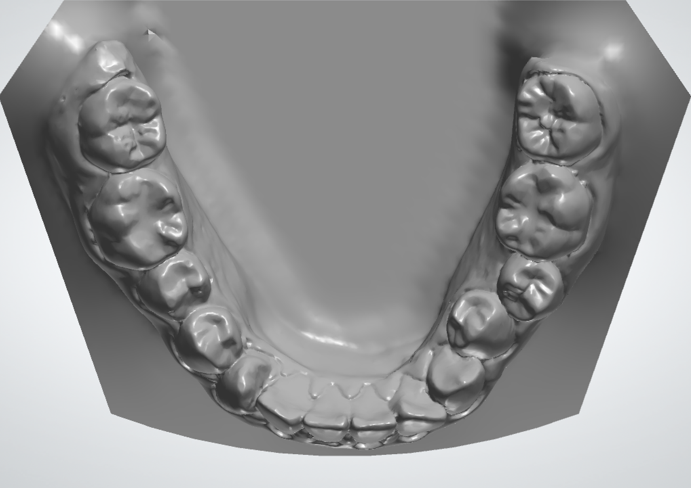
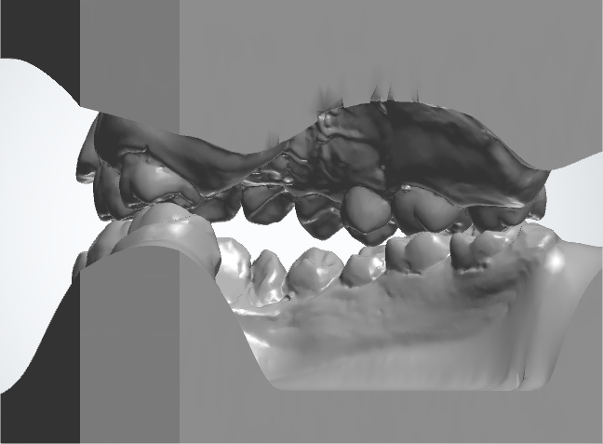
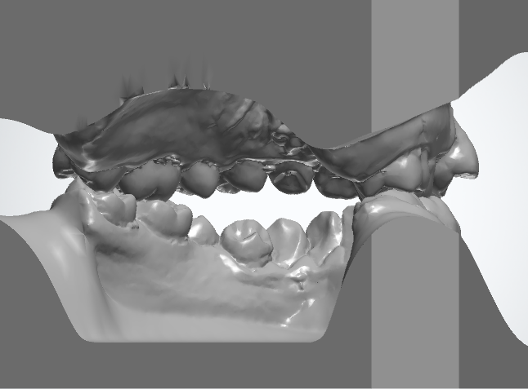
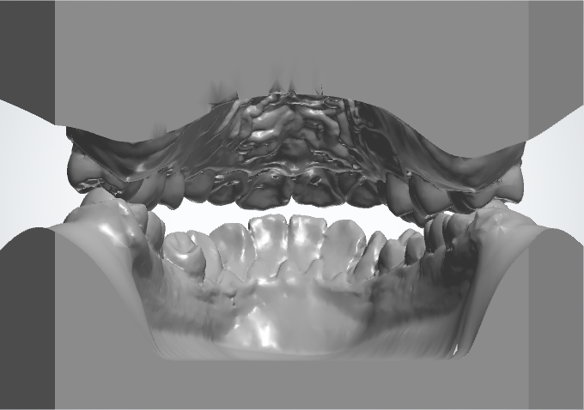
治療前之模型
Date: 2018.07.27
Age: 25Y5M

Pre-Treatment 齒列空間分析 (Dental Space Analysis)

Space analysis
(mm) | R’t | L’t
U/A | -8 | -9
L/A | -1.5 | -2.5

齒列大小分析 (Bolton Tooth Ratio Analysis)
 | Measurements | Norm | Correction
Anterior ratio | 80% | 77±1.65% | U +2 mm or L -1.5 mm
Overall ratio | 94% | 91±1.91% | U +3.5 mm or L -2.5 mm

治療前之側面測顱X光 (Pre-treatment Lateral Cephalogram)
攝影日期 (Date of X-ray)： 2018.07.27

治療前之側面測顱X光數據(Pre-treatment cephalometric analysis)：
 |  | PRE TX
SNA° |  | 76 | Upper 1 to NA mm | 3.5
SNB° |  | 76 | Upper 1 to SN° | 95.5
ANB° |  | 0 | Lower 1 to NB mm | 4.5
SN-MP° (Go-Gn) |  | 46.5 | Lower 1 to MP°(Go-Gn) | 75
E-Line mm | Upper | -4.5
E-Line mm | Lower | -0.5

治療紀錄 (Summary of Treatment)：
病患之主訴 (Chief Complaint)：
牙齒亂、前牙咬不到和下唇突。
病史 (History)：
Medical: Denied any major systemic disease and drug allergy
Dental: Under sporadic dental care

病因推斷 (Inference of Etiology)：
Basal bone discrepancy
Insufficient horizontal growth of maxilla
Excessive vertical and horizontal growth of mandible
Excessive upper posterior dental height
Tooth size-arch length discrepancy

診斷 (Diagnosis)：
骨骼性 (Skeletal)
  - Skeletal class III with maxilla retrognathism and mandible prognathism
  - High mandibular plane angle
  - Asymmetry (left side 2 mm chin deviation)

齒列性 (Dental)
- Angle’s Class I malocclusion
- Overjet: -0.5 mm; Overbite: -1.5 mm; Curve of Spee: 4 mm
- Midline:
Upper arch: on
Lower arch: L’t 1 mm
軟組織 (Soft tissue)
- Concave profile
- Upper lip retrusive to E-line
- 100% upper incisal show when smiling
- Facial proportion 1:1.25:1.25
- Lip incompetence with 5 mm interlabial gap
功能性 (Functional)
- No specific finding
治療目標 (Treatment Goals)：
AP: AnterioPosterior; VERT: Vertical; TRANS: Transverse; MX: Maxilla; MN: Mandible
Skeletal
AP MX | Advancement by surgery
AP MN | Setback by surgery
VERT MX
VERT MN
TRANS MX
TRANS MN
Dental
AP MX
AP MN
VERT Mx
VERT Md
TRANS MX
TRANS MN
CURVE OF SPEE
Esthetic
FACIAL ESTHETICS

治療計劃 (Treatment Plan)：
- 15, 24 extraction
- U/A: 23 retraction and decompensation
- L/A: Decompensation and Q3Q4 TADs for posterior teeth vertical control
- Lefort I advancement and wedge impaction
- BSSO setback and side shifting to right side
- Genioplasty for chin advancement
- Finish at Class I canine and Class II molar relationship
治療方法及裝置 (Treatment Methods and Appliances)：
- Bracket system: .022x.028 OPA-K system
- Sequential archwires for arch form coordination
- U/A: 23 retraction
- L/A: Q3Q4 TADs for posterior teeth vertical control
- Retention:
U/A: Vacuum formed retainer and wraparound retainer
L/A: Vacuum formed retainer and modified Hawley retainer

治療進展 (Treatment Progressing Note)：
Date | Upper Arch | Lower Arch
2018.08.17-  2018.11.15  (1-4M) | 15, 24 extraction  17-27 bonding (23 bypassed)  .016 NiTi  Leveling and alignment | 37-47 bonding  .016 NiTi  Leveling and alignment  32-42 IPR 1.5 mm
2018.12.21-  2019.03.08  (5-8M) | .018 SS (23 bypassed)  23 laceback | .018 NiTi Leveling and alignment  34, 35, 44, 45 IPR 1 mm  Q3Q4 screw for posterior teeth vertical control
2019.03.28-  2019.05.02  (9-11M) | .016x.022 SS (23 bypassed)  23 laceback | .016x.022 SS  Q3Q4 screw for posterior teeth intrusion
2019.06.26 | Take pre-surgery record for evaluation
2019.07.30  (12M) | Orthognathic surgery
2019.07.30  (12M) | Lefort I: Advance 2 mm (Point A)  Wedge Impaction (ANS upward 1.5 mm and PNS upward 3 mm) | BSSO: Setback 8 mm (Point B)  Side shifting 1.5 mm to right side  Genioplasty: Advance 2 mm (Pog.)  Lengthening 3 mm (Me.)
2019.09.11-  2019.10.02  (14-15M) | .014 NiTi (23 engaged)  Leveling and alignment | .016x.022 NiTi  37, 47 rebonding  Leveling and alignment
2019.11.01-  2029.12.03  (16-17M) | .016x.022 NiTi  Leveling and alignment | .016 x .022 NiTi  .016 x .022 SS Intrusive arch for L1 intrusion and proclination
2020.01.03-  2020.06.05  (18-23M) | .017x.025 TMA  22 Build-up  23 palatal root torque  Finishing and detailing | .017x.025 TMA  32-42 labial crown torque  33, 43 eminence  Finishing and detailing
2020.06.15  (23M) | 23 root coverage procedure
2020.07.14  (24M) | Debonding  Vacuum formed retainer delivery | Debonding  Vacuum formed retainer delivery
2020.08.21 | Wraparound retainer delivery | Hawley retainer delivery

Total Treatment Duration： 2Y
固持裝置 (Type of Retention)：
上齒列 (Maxillary Arch): Vacuum formed retainer + Wraparound retainer
裝載日期 (Date of Delivery): 2020.07.04, 2020.08.21
下齒列 (Mandibular Arch): Vacuum formed retainer + Modified Hawley retainer
裝載日期 (Date of Delivery): 2020.07.04, 2020.08.21

治療中之口內外照片 (Progress Photos Set 1) — All Photos in One Page
口內：1. 正面 2. 右側 3. 左側 4. 上顎咬合面 5. 下顎咬合面
口外：1. 正面 2. Posed Smile 3. 側面
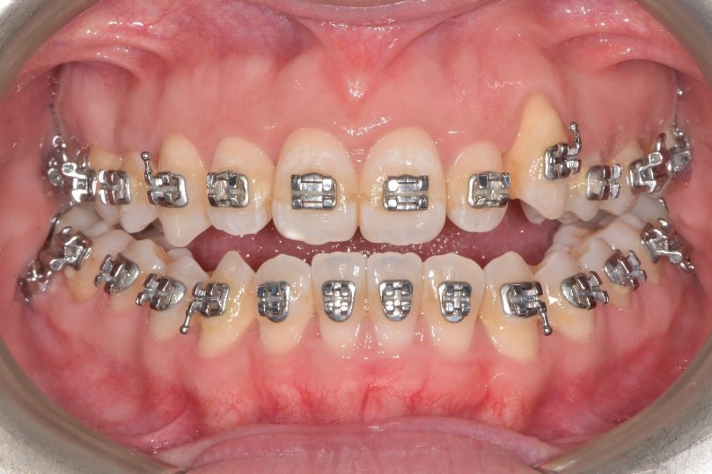
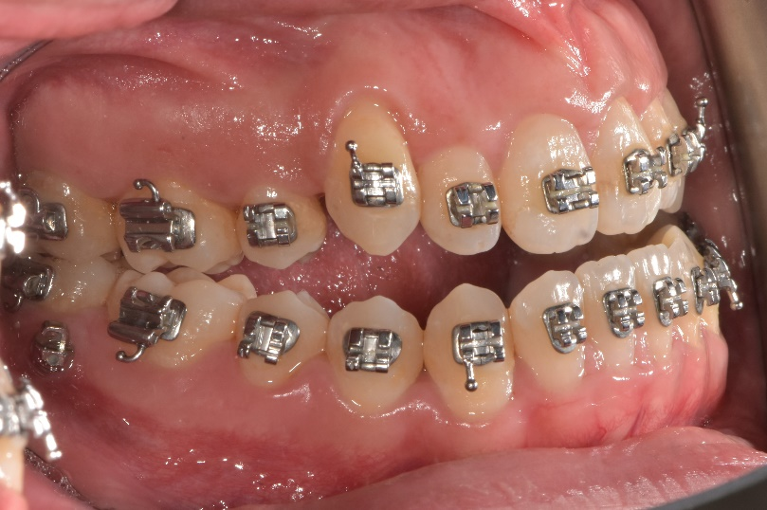
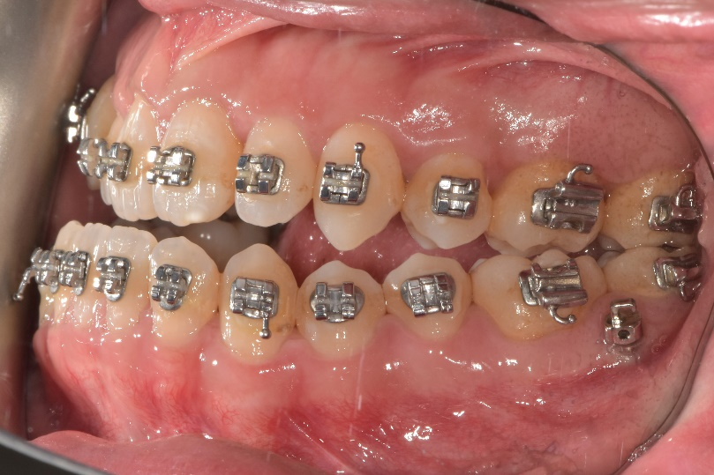
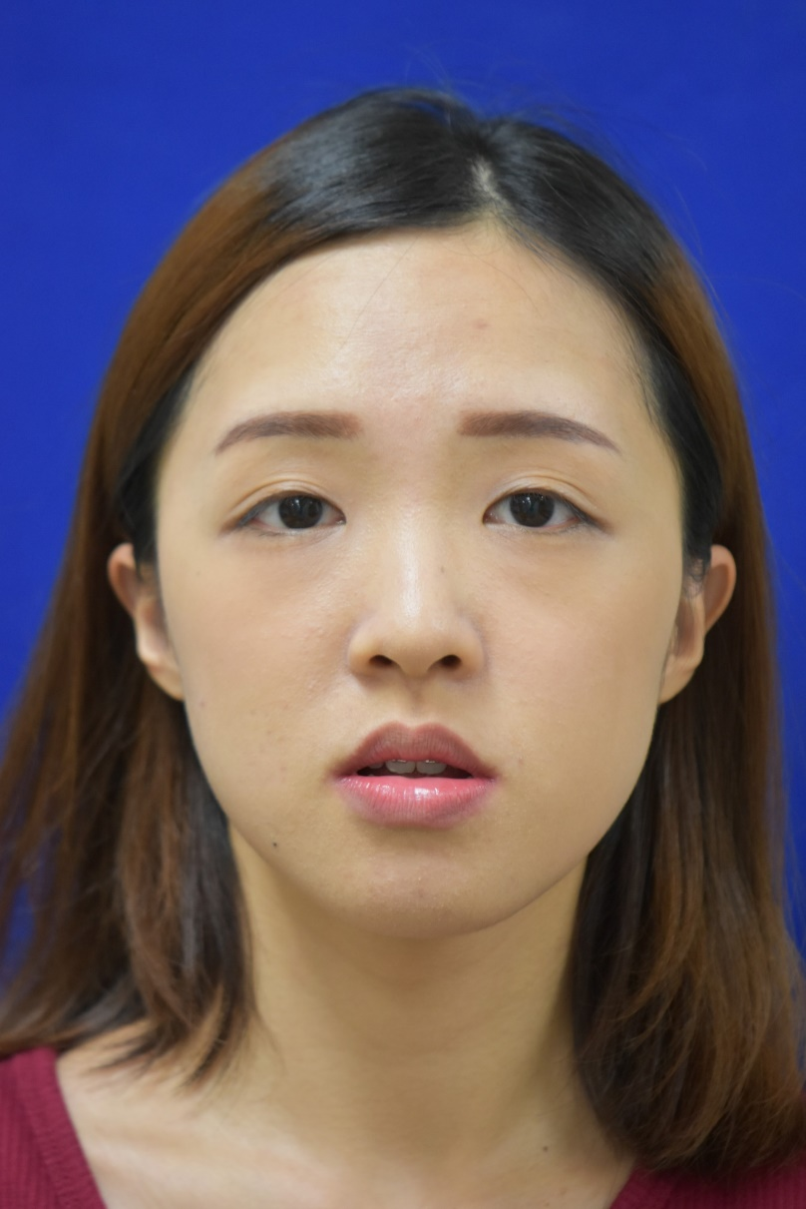
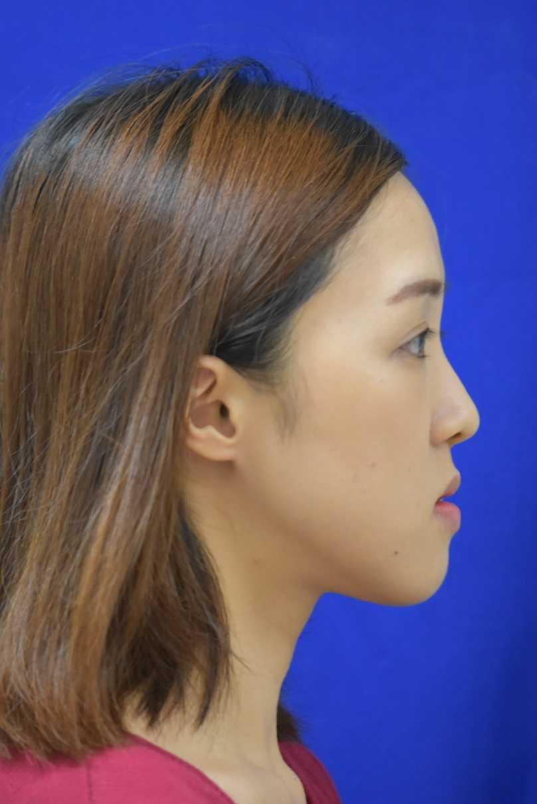
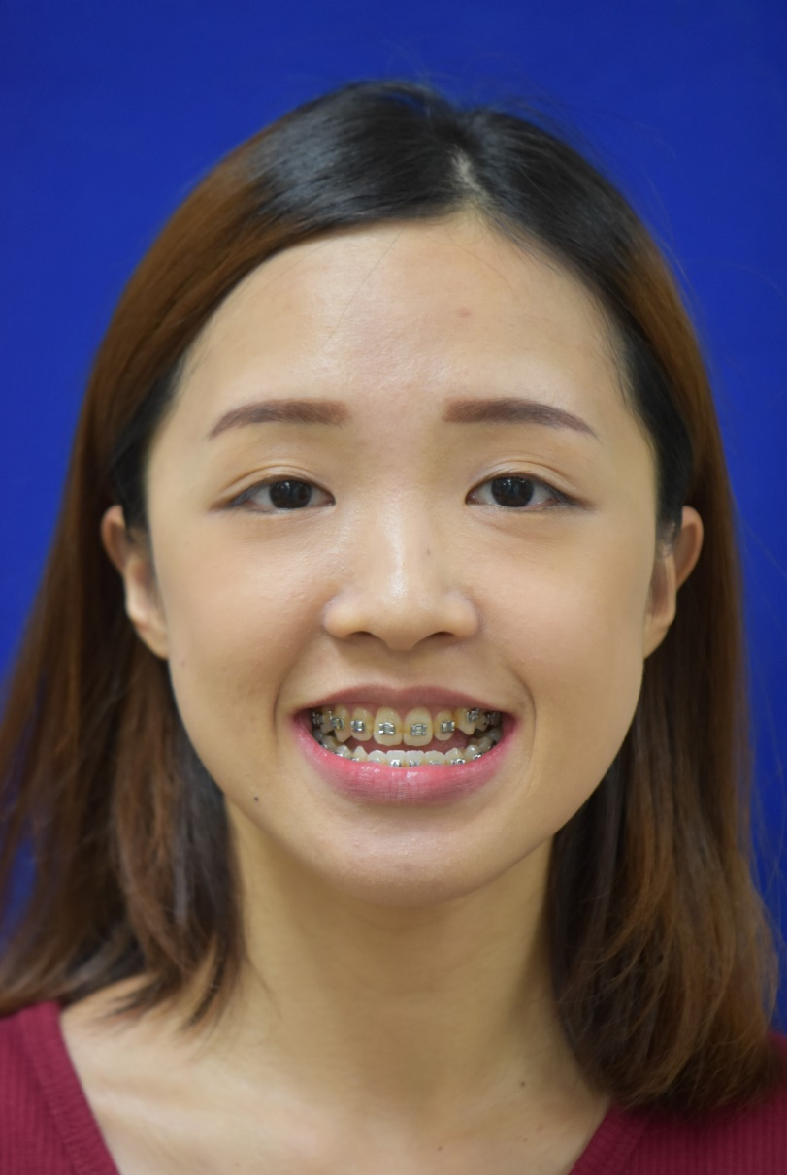
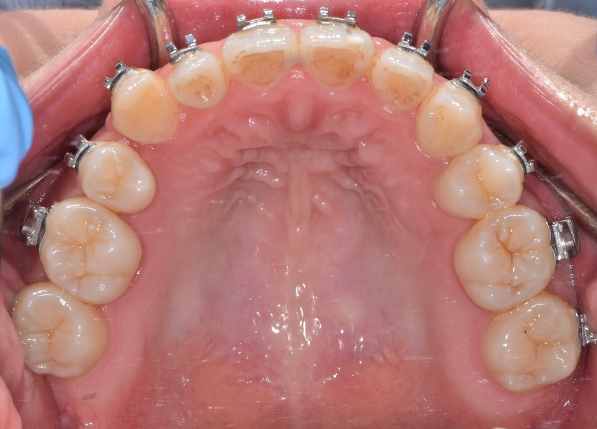
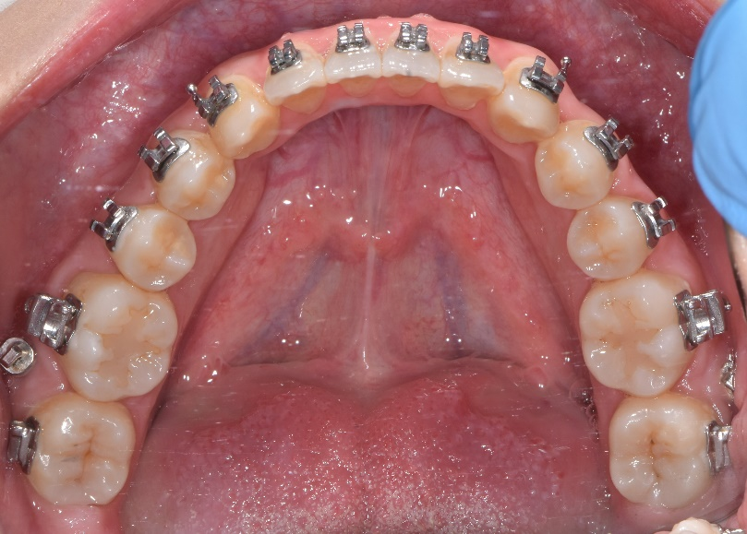
治療中之口內外照片
Date: 2019.06.26
Age: 26Y4M

治療後之口內外照片 (Post-treatment Intra- & Extra-oral Photos) — All photos in one page
口內：1. 正面 2. 右側 3. 左側 4. 上顎咬合面 5. 下顎咬合面
口外：1. 正面 2. Posed Smile 3. 側面
治療後之口內外照片
Date: 2020.07.14
Age: 27Y5M
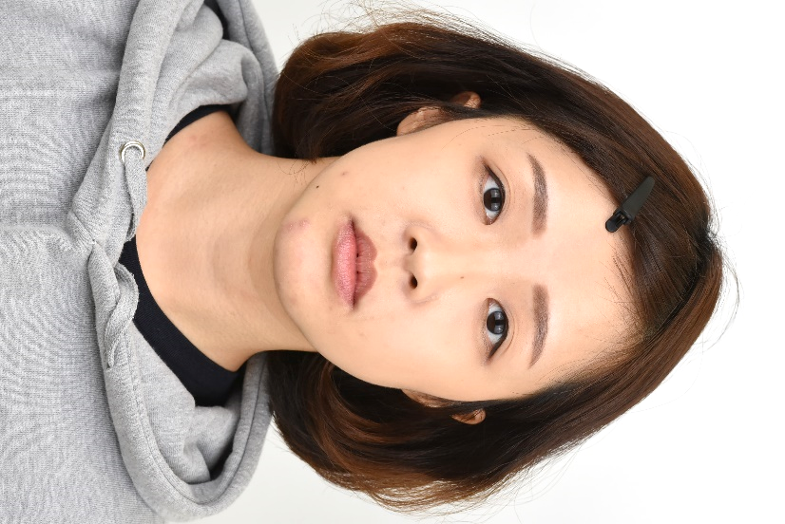
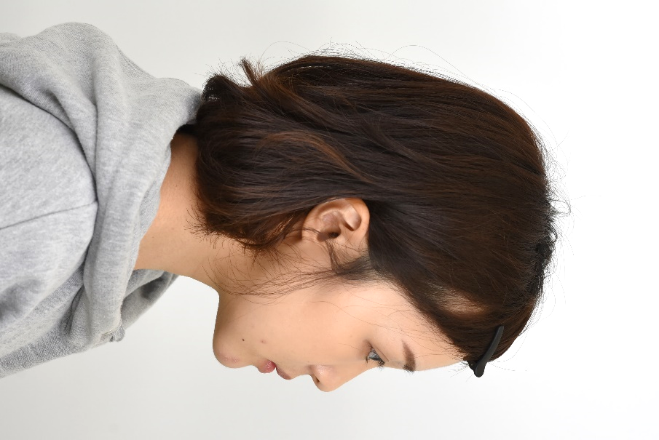
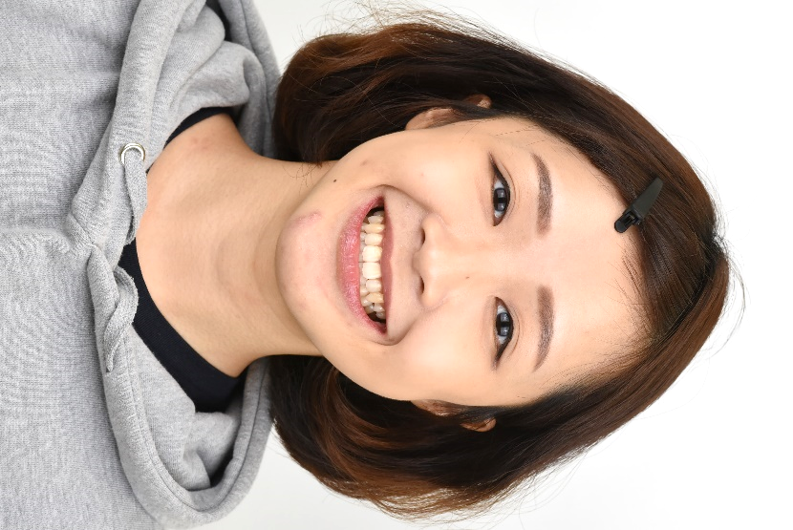
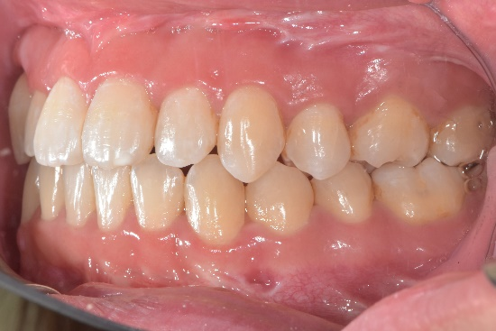
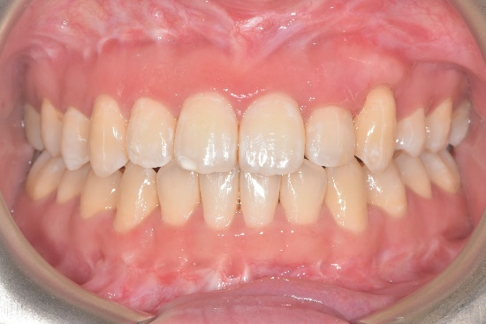
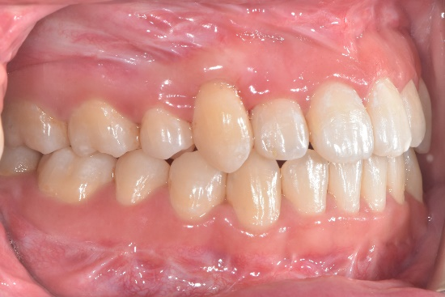
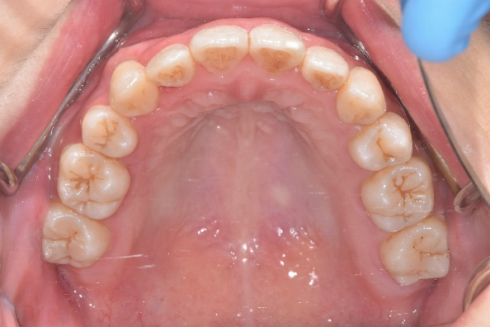
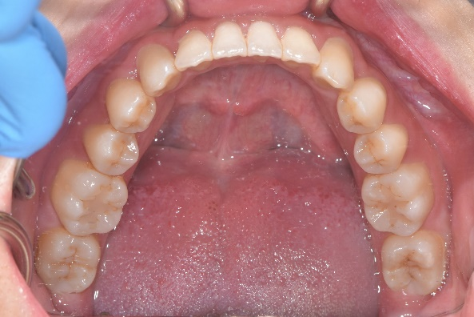

治療後之側面測顱X光 (Post-treatment Lateral Cephalogram)
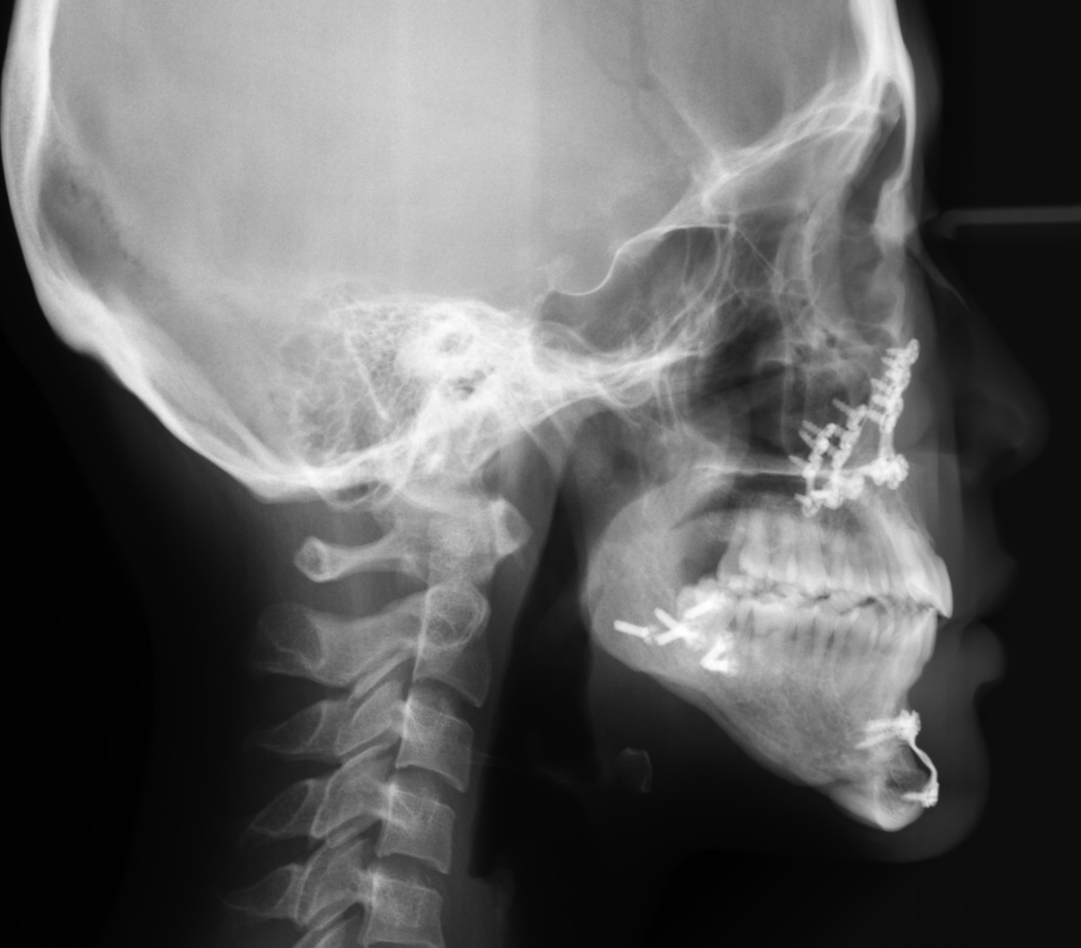
攝影日期 (Date of X-ray)： 2020.07.14

治療後之側面測顱X光數據(Post-treatment cephalometric analysis)：
 |  | post TX
SNA° |  | 77 | Upper 1 to NA mm | 4.5
SNB° |  | 74 | Upper 1 to SN° | 101.5
ANB° |  | 3 | Lower 1 to NB mm | 5
SN-MP° (Go-Gn) |  | 42 | Lower 1 to MP°(Go-Gn) | 85
E-Line mm | Upper | -05
E-Line mm | Lower | -0.5

治療前之環口X光 (Pre-treatment Panoramic Radiograph) （本頁請附實體Pano）
攝影日期 (Date of X-ray): 2018.07.27
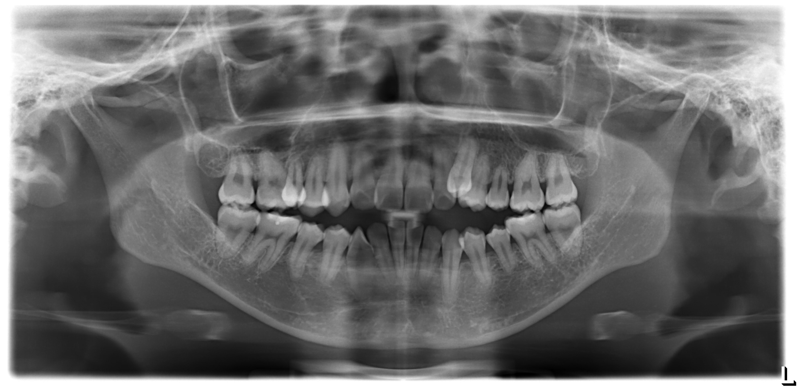

治療後之環口X光 (Post-treatment Panoramic Radiograph)
攝影日期 (Date of X-ray): 2020.07.14

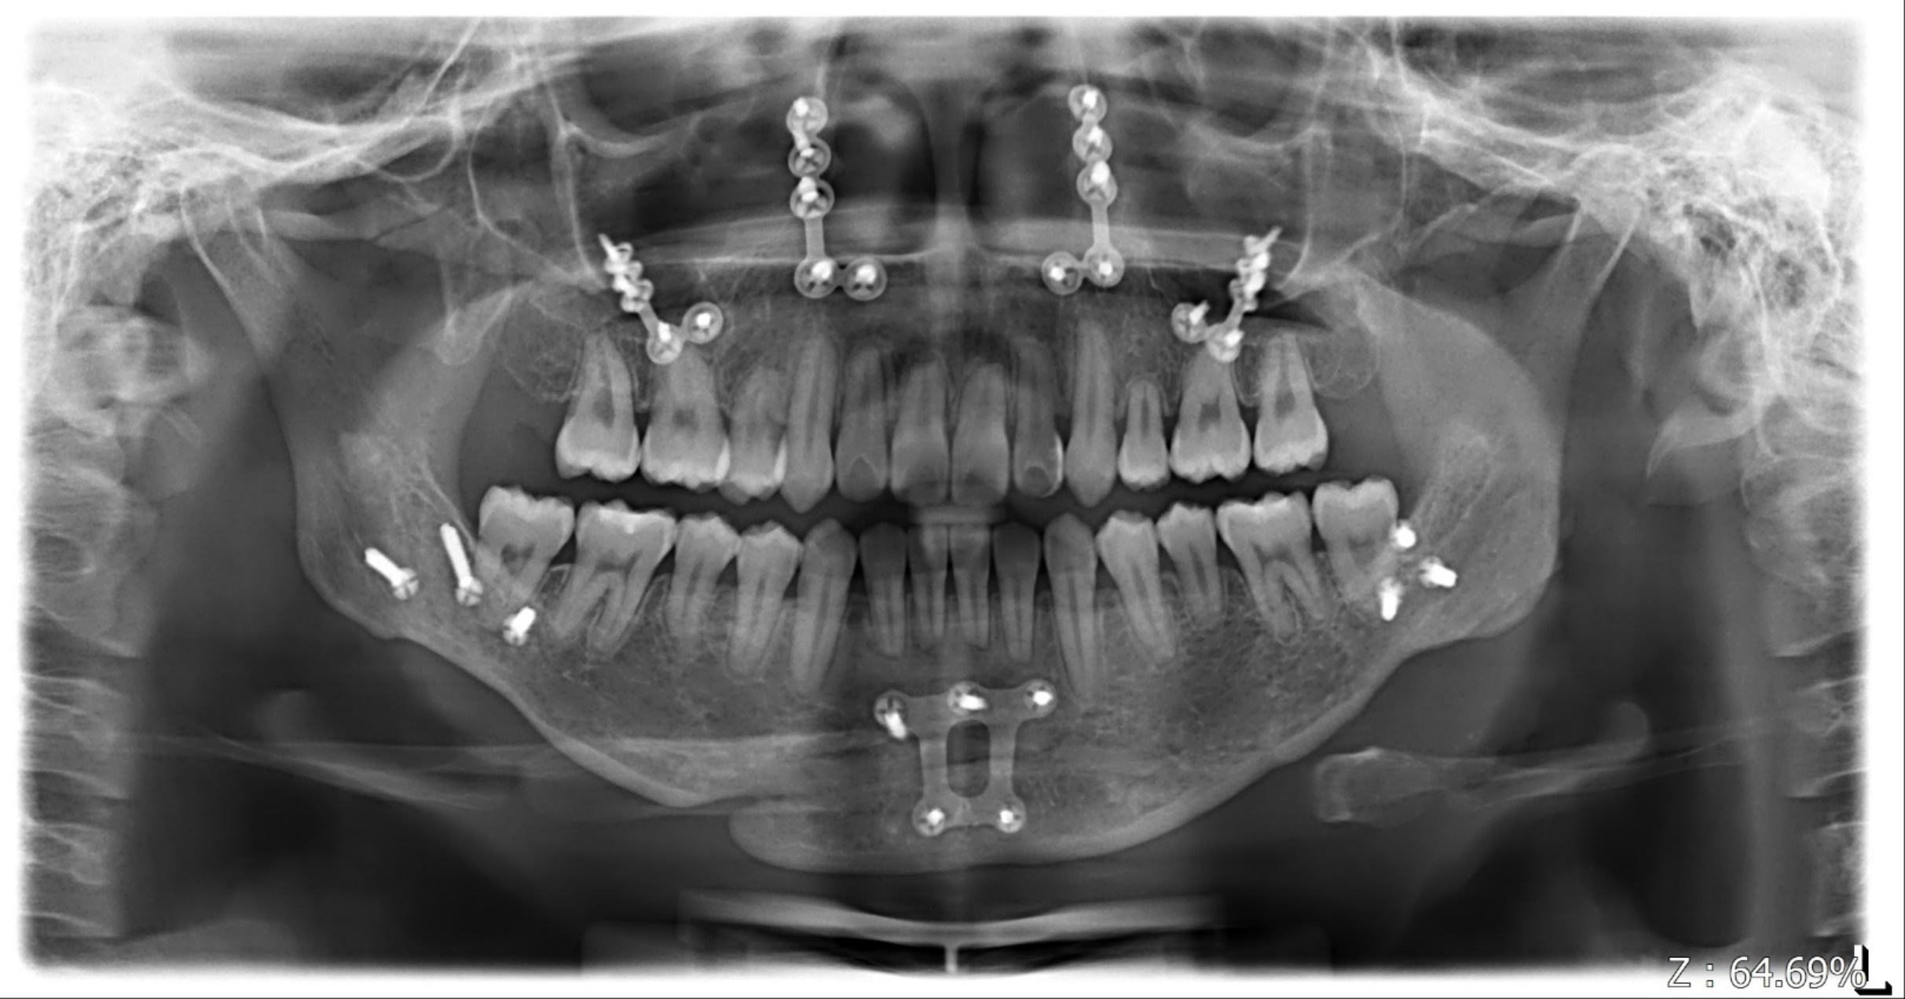

治療後之模型照片 (Post-treatment Dental Model Photos) — All photos in one page
1. 正面 2. 右側 3. 左側 4. 上顎咬合面 5. 下顎咬合面 6. 舌側正面 7. 舌側右面 8. 舌側左面
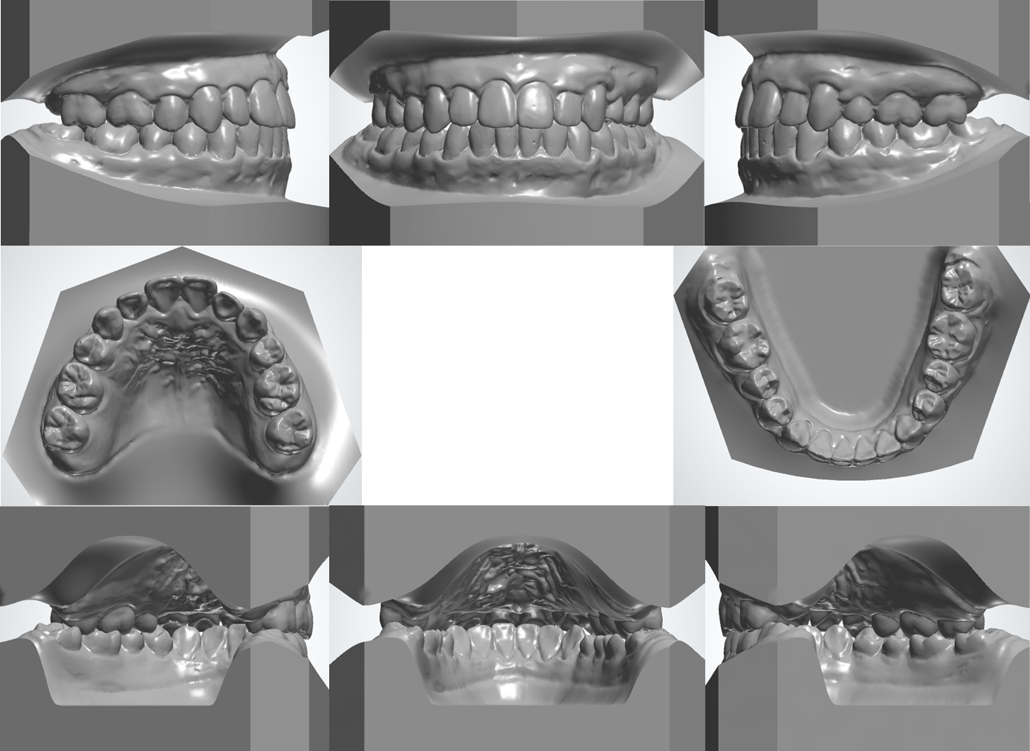
治療後之模型照片
Date: 2020.07.14
Age: 27Y5M

治療前之側面測顱X光臨摹 (Pre-treatment Cephalometric Tracing)：
（本頁請附實體tracing和CEPH）
攝影日期 (Date of X-ray)： 2018.07.27

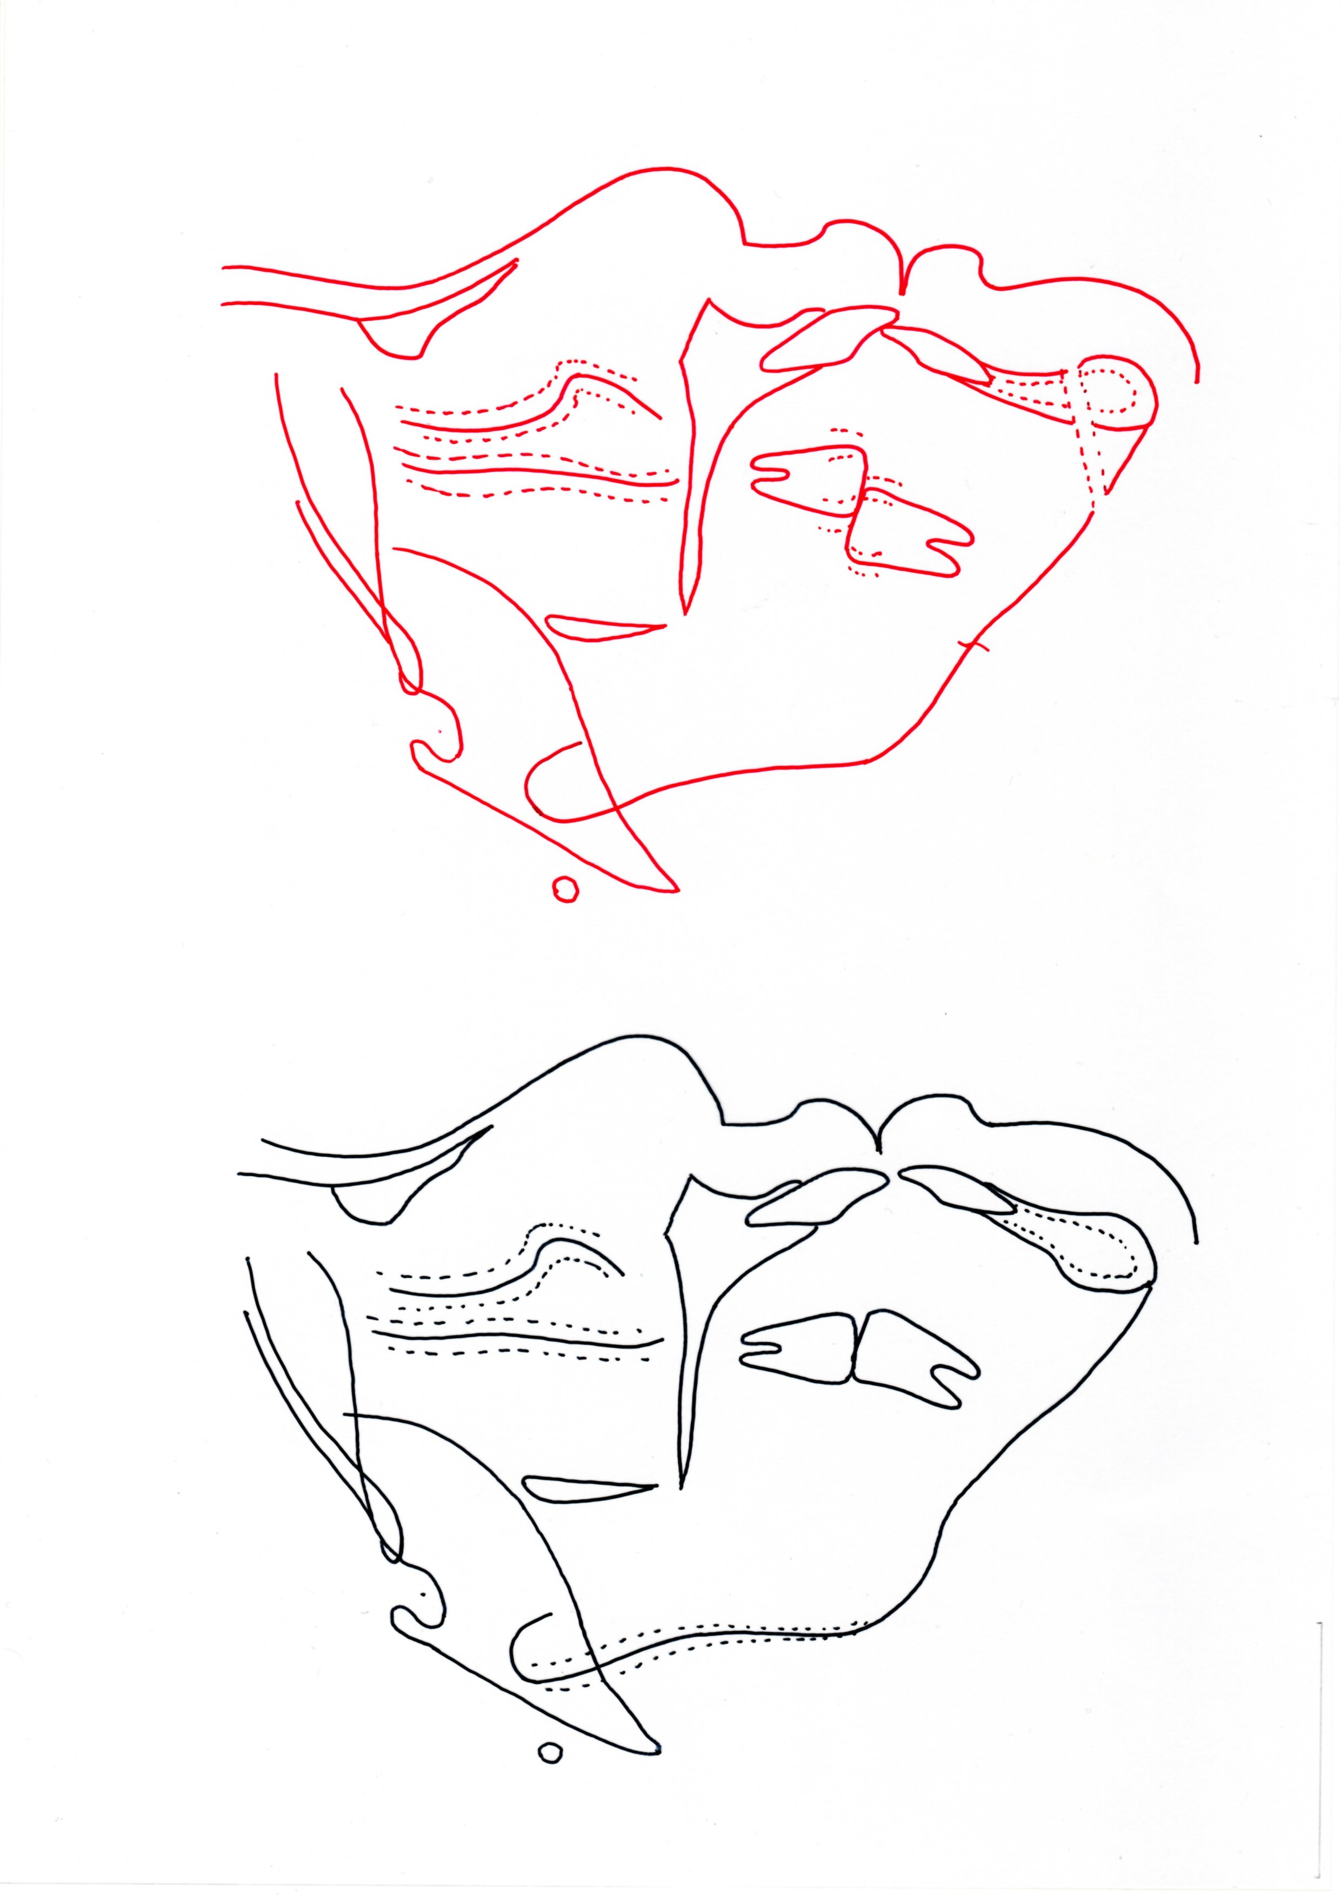

治療後之側面測顱X光臨摹 (Post-treatment Cephalometric Tracing)：
（本頁請附實體tracing 和Ceph）
攝影日期 (Date of X-ray)： 2020.07.14

治療前後之側面測顱X光臨摹全重疊與結果闡釋說明(Interpretation of the pre-treatment and post-treatment overall cephalometric superimposition & results)----定位於S點，重疊於S-N line上 (Register on S point and superimpose on S-N line)
- Maxilla: Advance 2 mm (Point A)
Wedge impaction (ANS upward 1.5 mm and PNS upward 3 mm)
- Mandible: Setback 8 mm (Point B)
Counter-clockwise rotation (SM-MP decreased 4.5°)
Anterior facial height decreased 4 mm (Me)
- Upper lip: Forward 3 mm
- Lower lip: Retracted 2 mm
（本頁請附實體tracing）
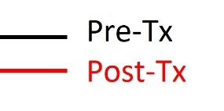
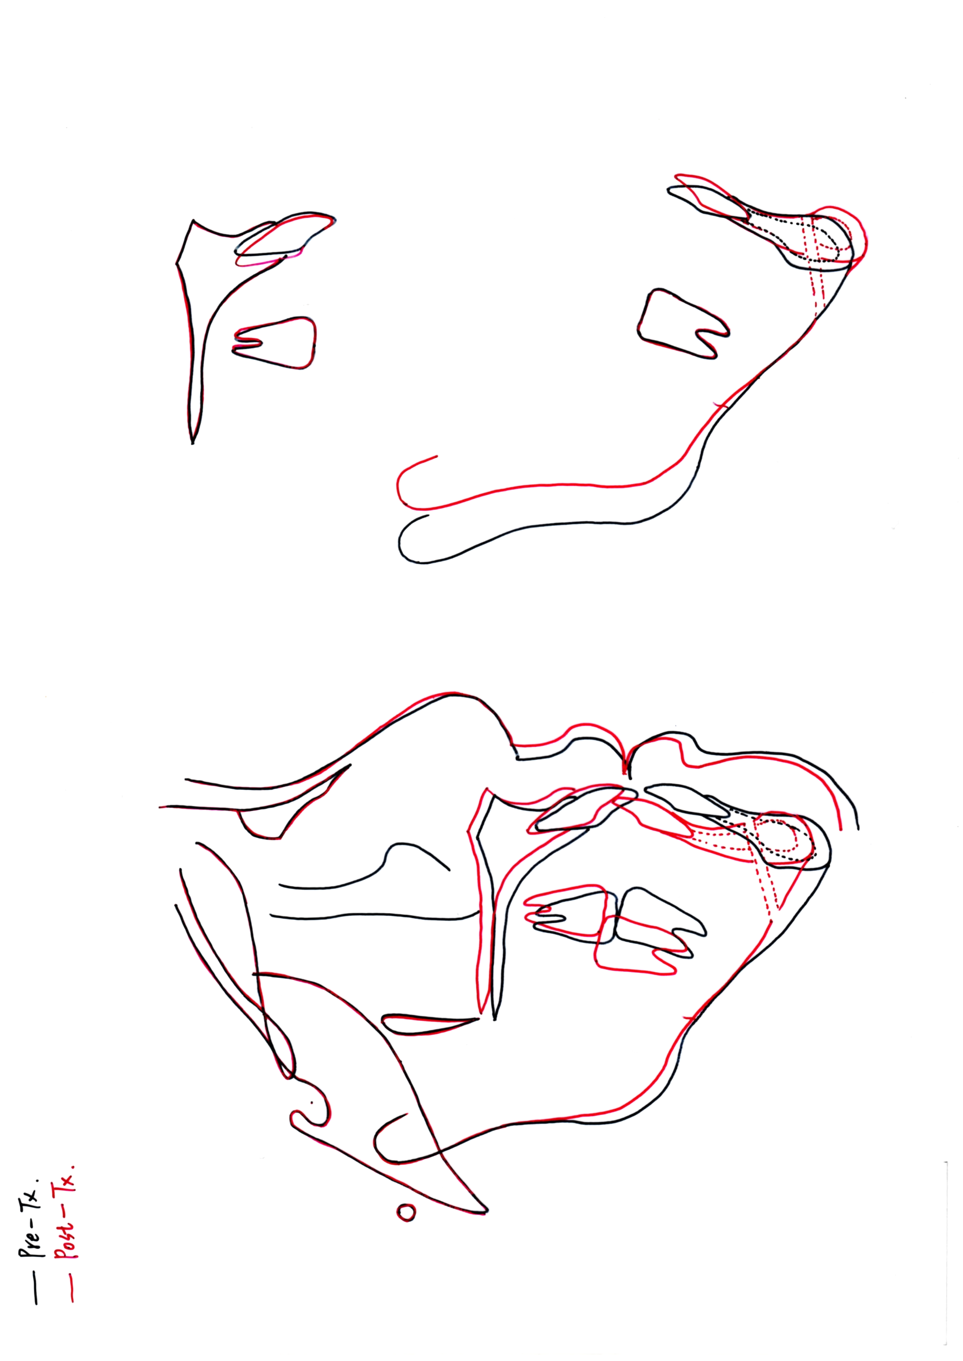
治療前後之上顎骨臨摹重疊與結果闡釋說明---請註明定位點與重疊平面 (Please describe the method of superimposition)： 定位於 palatal plane，重疊於 Palatal curvature
（本頁請附實體tracing）
- U1: Palatal root movement 2 mm
- U6: Maintained

治療前後之下顎骨臨摹重疊與結果闡釋說明--請註明定位點與重疊平面 (Please describe the method of superimposition)：定位於 Inner cortex of symphysis，重疊於 Mandibular plane
- L1: Proclined 3 mm
- L6: Maintained

評估治療前後之側面測顱X光數據變化 (Pre-treatment and post-treatment cephalometric analysis)：

SKELETAL ANALYSIS
 |  | PRE TX | POST TX
SNA° |  | 76 | 77
SNB° |  | 76 | 74
ANB° |  | 0 | 3
SN-MP° (Go-Gn) |  | 46.5 | 42
DENTAL ANALYSIS
Upper 1 to NA mm |  | 3.5 | 4.5
Upper 1 to SN° |  | 95.5 | 101.5
Lower 1 to NB mm |  | 4.5 | 5
Lower 1 to MP°(Go-Gn) |  | 75 | 85
FACIAL ANALYSIS
E-Line mm | Upper | -4.5 | -0.5
E-Line mm | Lower | -0.5 | -0.5

治療前病例難易度（新版）
空白處考生自我評分 ，並於( )處勾選患者年紀，由評審委員審查正確性
MEASUREMENTS
SCORE FOR SKELETAL ANALYSIS (S)
 |  | PRE TX (A) | （ ）Norm小於15歲 |  | （ V ）Norm>=15歲 |  | 評分標準 | 自評得分
 |  | PRE TX (A) | Male | Female | Male | Female | 評分標準 | 自評得分
SNA° |  | 76 | 78.92~85.22 | 79.1~85.62 | 80.59~87.45 | 79.72~86.1
SNB° |  | 76 | 75.81~81.71 | 76.27~82.43 | 77.76~84.1 | 77.6~83.7
ANB° |  | 0 | 1.53~5.11 | 1.2~4.76 | 1.4~5.02 | 0.7~3.8 | 2 | 0
SN-MP°(Go-Gn) |  | 46.5 | 28.67~36.97 | 28.17~37.01 | 23.31~35.05 | 25.52~34.48 | 2 | 0
SCORE FOR DENTAL ANALYSIS（D）
Upper 1 to NA mm |  | 3.5 | 2.71~6.99 | 2.93~6.63 | 2.01~6.75 | 3.18~7.34
Upper 1 to SN° |  | 95.5 | 100.94~112.88 | 100.70~112.92 | 103.38~114.42 | 102.23~115.13 | 2 | 2
Lower 1 to NB mm |  | 4.5 | 4.34~8.34 | 3.84~7.46 | 4.05~8.97 | 4~8.44
Lower 1 to MP°(Go-Gn) |  | 75 | 92.06~104.0 | 90.81~102.75 | 91.68~104.84 | 90.56~103.12 | 2 | 2
SCORE FOR FACIAL ANALYSIS（F）
E-LINE | Upper | -4.5 | -0.37~1.01 | -2.93~0.41 | -0.37~1.01 | -2.93~0.41 | 1 | 0
E-LINE | Lower | -0.5 | -1.24~2.48 | -1.86~2.1 | -1.24~2.48 | -1.86~2.1 | 1 | 0
SCORE FOR MODEL ANALYSIS (M)
Overjet |  | -0.5 | 0.0 ~ 5.0 |  |  |  | 1 | 0
Overbite |  | -1.5 | 0.0 ~ 4.0 |  |  |  | 1 | 0
Midlines |  | L/A: L’t 1 mm | 0.0 ~ 2.0 |  |  |  | 1 | 0
Canine relationship |  | R’t: Class III 4 mm  L’t: Class II 3 mm | 上顎canine cusp tip咬在下顎 canine-premolar embrasure前後 2.0 mm 以內 |  |  |  | 1 | 0
Molar relationship |  | Class I | 上顎第一大臼齒的近心頰側咬頭的三角隆線(Triangular Ridge)咬在下顎第一大臼齒的近心頰側溝(Mesiobuccal Groove)近/遠心2.0 mm以內 |  |  |  | 1 | 0
總得分 |  |  |  |  |  |  |  | 4
評分說明
測量錯誤 或 測量值在正常範圍內（不困難）：不得分
以手術改善變異之項目（如ANB, SN-MP, OJ, midline, canine molar relation….等）：不得分
以Anterio osteotomy 改善Ｕ1 ,L1變異者 ：不得分

治療前病例難易度（新版）
空白處考生自我評分 ，並於( )處勾選患者年紀，由評審委員審查正確性
MEASUREMENTS
SCORE FOR SKELETAL ANALYSIS (S)
 |  | PRE TX (A) | （ ）Norm小於15歲 |  | （ V ）Norm>=15歲 |  | 評分標準 | 自評得分
 |  | PRE TX (A) | Male | Female | Male | Female | 評分標準 | 自評得分
SNA° |  |  | 78.92~85.22 | 79.1~85.62 | 80.59~87.45 | 79.72~86.1
SNB° |  |  | 75.81~81.71 | 76.27~82.43 | 77.76~84.1 | 77.6~83.7
ANB° |  |  | 1.53~5.11 | 1.2~4.76 | 1.4~5.02 | 0.7~3.8 | 2
SN-MP°(Go-Gn) |  |  | 28.67~36.97 | 28.17~37.01 | 23.31~35.05 | 25.52~34.48 | 2
SCORE FOR DENTAL ANALYSIS（D）
Upper 1 to NA mm |  |  | 2.71~6.99 | 2.93~6.63 | 2.01~6.75 | 3.18~7.34
Upper 1 to SN° |  |  | 100.94~112.88 | 100.70~112.92 | 103.38~114.42 | 102.23~115.13 | 2
Lower 1 to NB mm |  |  | 4.34~8.34 | 3.84~7.46 | 4.05~8.97 | 4~8.44
Lower 1 to MP°(Go-Gn) |  |  | 92.06~104.0 | 90.81~102.75 | 91.68~104.84 | 90.56~103.12 | 2
SCORE FOR FACIAL ANALYSIS（F）
E-LINE | Upper |  | -0.37~1.01 | -2.93~0.41 | -0.37~1.01 | -2.93~0.41 | 1
E-LINE | Lower |  | -1.24~2.48 | -1.86~2.1 | -1.24~2.48 | -1.86~2.1 | 1
SCORE FOR MODEL ANALYSIS (M)
Overjet |  |  | 0.0 ~ 5.0 |  |  |  | 1
Overbite |  |  | 0.0 ~ 4.0 |  |  |  | 1
Midlines |  |  | 0.0 ~ 2.0 |  |  |  | 1
Canine relationship |  |  | 上顎canine cusp tip咬在下顎 canine-premolar embrasure前後 2.0 mm 以內 |  |  |  | 1
Molar relationship |  |  | 上顎第一大臼齒的近心頰側咬頭的三角隆線(Triangular Ridge)咬在下顎第一大臼齒的近心頰側溝(Mesiobuccal Groove)近/遠心2.0 mm以內 |  |  |  | 1
總得分
評分說明
測量錯誤 或 測量值在正常範圍內（不困難）：不得分
以手術改善變異之項目（如ANB, SN-MP, OJ, midline, canine molar relation….等）：不得分
以Anterio osteotomy 改善Ｕ1 ,L1變異者 ：不得分

治療前病例難易度（新版）
空白處考生自我評分 ，並於( )處勾選患者年紀，由評審委員審查正確性
MEASUREMENTS
SCORE FOR SKELETAL ANALYSIS (S)
 |  | PRE TX (A) | （ V ）Norm小於15歲 |  | （ ）Norm>=15歲 |  | 評分標準 | 自評得分
 |  | PRE TX (A) | Male | Female | Male | Female | 評分標準 | 自評得分
SNA° |  |  | 78.92~85.22 | 79.1~85.62 | 80.59~87.45 | 79.72~86.1
SNB° |  |  | 75.81~81.71 | 76.27~82.43 | 77.76~84.1 | 77.6~83.7
ANB° |  |  | 1.53~5.11 | 1.2~4.76 | 1.4~5.02 | 0.7~3.8 | 2
SN-MP°(Go-Gn) |  |  | 28.67~36.97 | 28.17~37.01 | 23.31~35.05 | 25.52~34.48 | 2
SCORE FOR DENTAL ANALYSIS（D）
Upper 1 to NA mm |  |  | 2.71~6.99 | 2.93~6.63 | 2.01~6.75 | 3.18~7.34
Upper 1 to SN° |  |  | 100.94~112.88 | 100.70~112.92 | 103.38~114.42 | 102.23~115.13 | 2
Lower 1 to NB mm |  |  | 4.34~8.34 | 3.84~7.46 | 4.05~8.97 | 4~8.44
Lower 1 to MP°(Go-Gn) |  |  | 92.06~104.0 | 90.81~102.75 | 91.68~104.84 | 90.56~103.12 | 2
SCORE FOR FACIAL ANALYSIS（F）
E-LINE | Upper |  | -0.37~1.01 | -2.93~0.41 | -0.37~1.01 | -2.93~0.41 | 1
E-LINE | Lower |  | -1.24~2.48 | -1.86~2.1 | -1.24~2.48 | -1.86~2.1 | 1
SCORE FOR MODEL ANALYSIS (M)
Overjet |  |  | 0.0 ~ 5.0 |  |  |  | 1
Overbite |  |  | 0.0 ~ 4.0 |  |  |  | 1
Midlines |  |  | 0.0 ~ 2.0 |  |  |  | 1
Canine relationship |  |  | 上顎canine cusp tip咬在下顎 canine-premolar embrasure前後 2.0 mm 以內 |  |  |  | 1
Molar relationship |  |  | 上顎第一大臼齒的近心頰側咬頭的三角隆線(Triangular Ridge)咬在下顎第一大臼齒的近心頰側溝(Mesiobuccal Groove)近/遠心2.0 mm以內 |  |  |  | 1
總得分
評分說明
測量錯誤 或 測量值在正常範圍內（不困難）：不得分
以手術改善變異之項目（如ANB, SN-MP, OJ, midline, canine molar relation….等）：不得分
以Anterio osteotomy 改善Ｕ1 ,L1變異者 ：不得分

治療前病例難易度（新版）
空白處考生自我評分 ，並於( )處勾選患者年紀，由評審委員審查正確性
MEASUREMENTS
SCORE FOR SKELETAL ANALYSIS (S)
 |  | PRE TX (A) | （ V ）Norm小於15歲 |  | （ ）Norm>=15歲 |  | 評分標準 | 自評得分
 |  | PRE TX (A) | Male | Female | Male | Female | 評分標準 | 自評得分
SNA° |  |  | 78.92~85.22 | 79.1~85.62 | 80.59~87.45 | 79.72~86.1
SNB° |  |  | 75.81~81.71 | 76.27~82.43 | 77.76~84.1 | 77.6~83.7
ANB° |  |  | 1.53~5.11 | 1.2~4.76 | 1.4~5.02 | 0.7~3.8 | 2
SN-MP°(Go-Gn) |  |  | 28.67~36.97 | 28.17~37.01 | 23.31~35.05 | 25.52~34.48 | 2
SCORE FOR DENTAL ANALYSIS（D）
Upper 1 to NA mm |  |  | 2.71~6.99 | 2.93~6.63 | 2.01~6.75 | 3.18~7.34
Upper 1 to SN° |  |  | 100.94~112.88 | 100.70~112.92 | 103.38~114.42 | 102.23~115.13 | 2
Lower 1 to NB mm |  |  | 4.34~8.34 | 3.84~7.46 | 4.05~8.97 | 4~8.44
Lower 1 to MP°(Go-Gn) |  |  | 92.06~104.0 | 90.81~102.75 | 91.68~104.84 | 90.56~103.12 | 2
SCORE FOR FACIAL ANALYSIS（F）
E-LINE | Upper |  | -0.37~1.01 | -2.93~0.41 | -0.37~1.01 | -2.93~0.41 | 1
E-LINE | Lower |  | -1.24~2.48 | -1.86~2.1 | -1.24~2.48 | -1.86~2.1 | 1
SCORE FOR MODEL ANALYSIS (M)
Overjet |  |  | 0.0 ~ 5.0 |  |  |  | 1
Overbite |  |  | 0.0 ~ 4.0 |  |  |  | 1
Midlines |  |  | 0.0 ~ 2.0 |  |  |  | 1
Canine relationship |  |  | 上顎canine cusp tip咬在下顎 canine-premolar embrasure前後 2.0 mm 以內 |  |  |  | 1
Molar relationship |  |  | 上顎第一大臼齒的近心頰側咬頭的三角隆線(Triangular Ridge)咬在下顎第一大臼齒的近心頰側溝(Mesiobuccal Groove)近/遠心2.0 mm以內 |  |  |  | 1
總得分
評分說明
測量錯誤 或 測量值在正常範圍內（不困難）：不得分
以手術改善變異之項目（如ANB, SN-MP, OJ, midline, canine molar relation….等）：不得分
以Anterio osteotomy 改善Ｕ1 ,L1變異者 ：不得分

治療目標與達成情形分析 (Treatment Goals setting and Achieved)

 | Treatment goal | Tx goal achievement
Skeletal
AP MX
AP MN
VERT MX
VERT MN
TRANS MX
TRANS MN
Dental
AP MX
AP MN
VERT Mx
Vert MN
TRANS MX
TRANS MN
CURVE OF SPEE
Esthetic
FACIAL ESTHETICS

AP: AnterioPosterior; VERT: Vertical; TRANS: Transverse; MX: Maxilla; MN: Mandible

矯正結果自我評估 (Self-assessment of Treatment Results)：
- 牙齒排列仍有改善空間:
- 應加強#13, #33 Mesial-out和#12, #32 Distal- in rotation，讓牙弓連續性更好。
- #25應再step down一些，達到更solid咬合關係。

其他佐證資料：
正顎手術前之側面測顱X光 (Pre-OP Lateral Cephalogram)
攝影日期 (Date of X-ray)： 2019.06.25
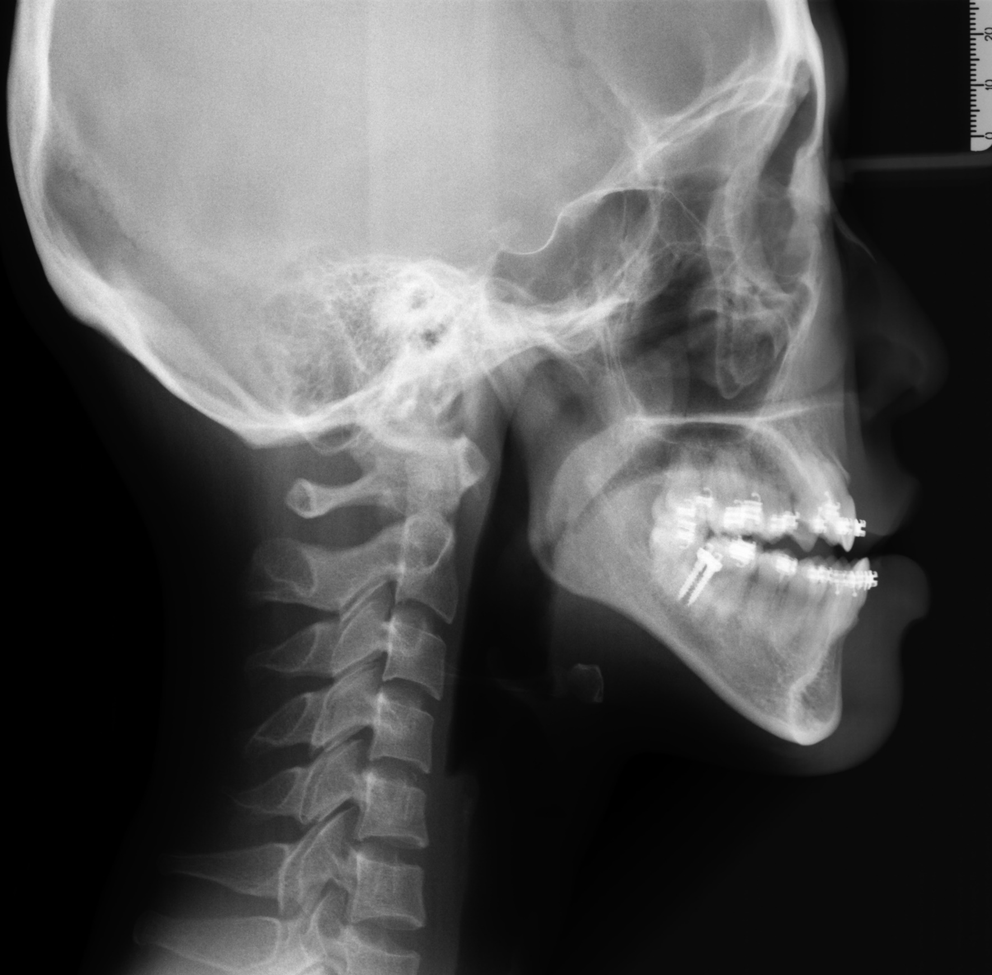

正顎手術後之側面測顱X光 (Post-OP Lateral Cephalogram)
攝影日期 (Date of X-ray)： 2019.08.07
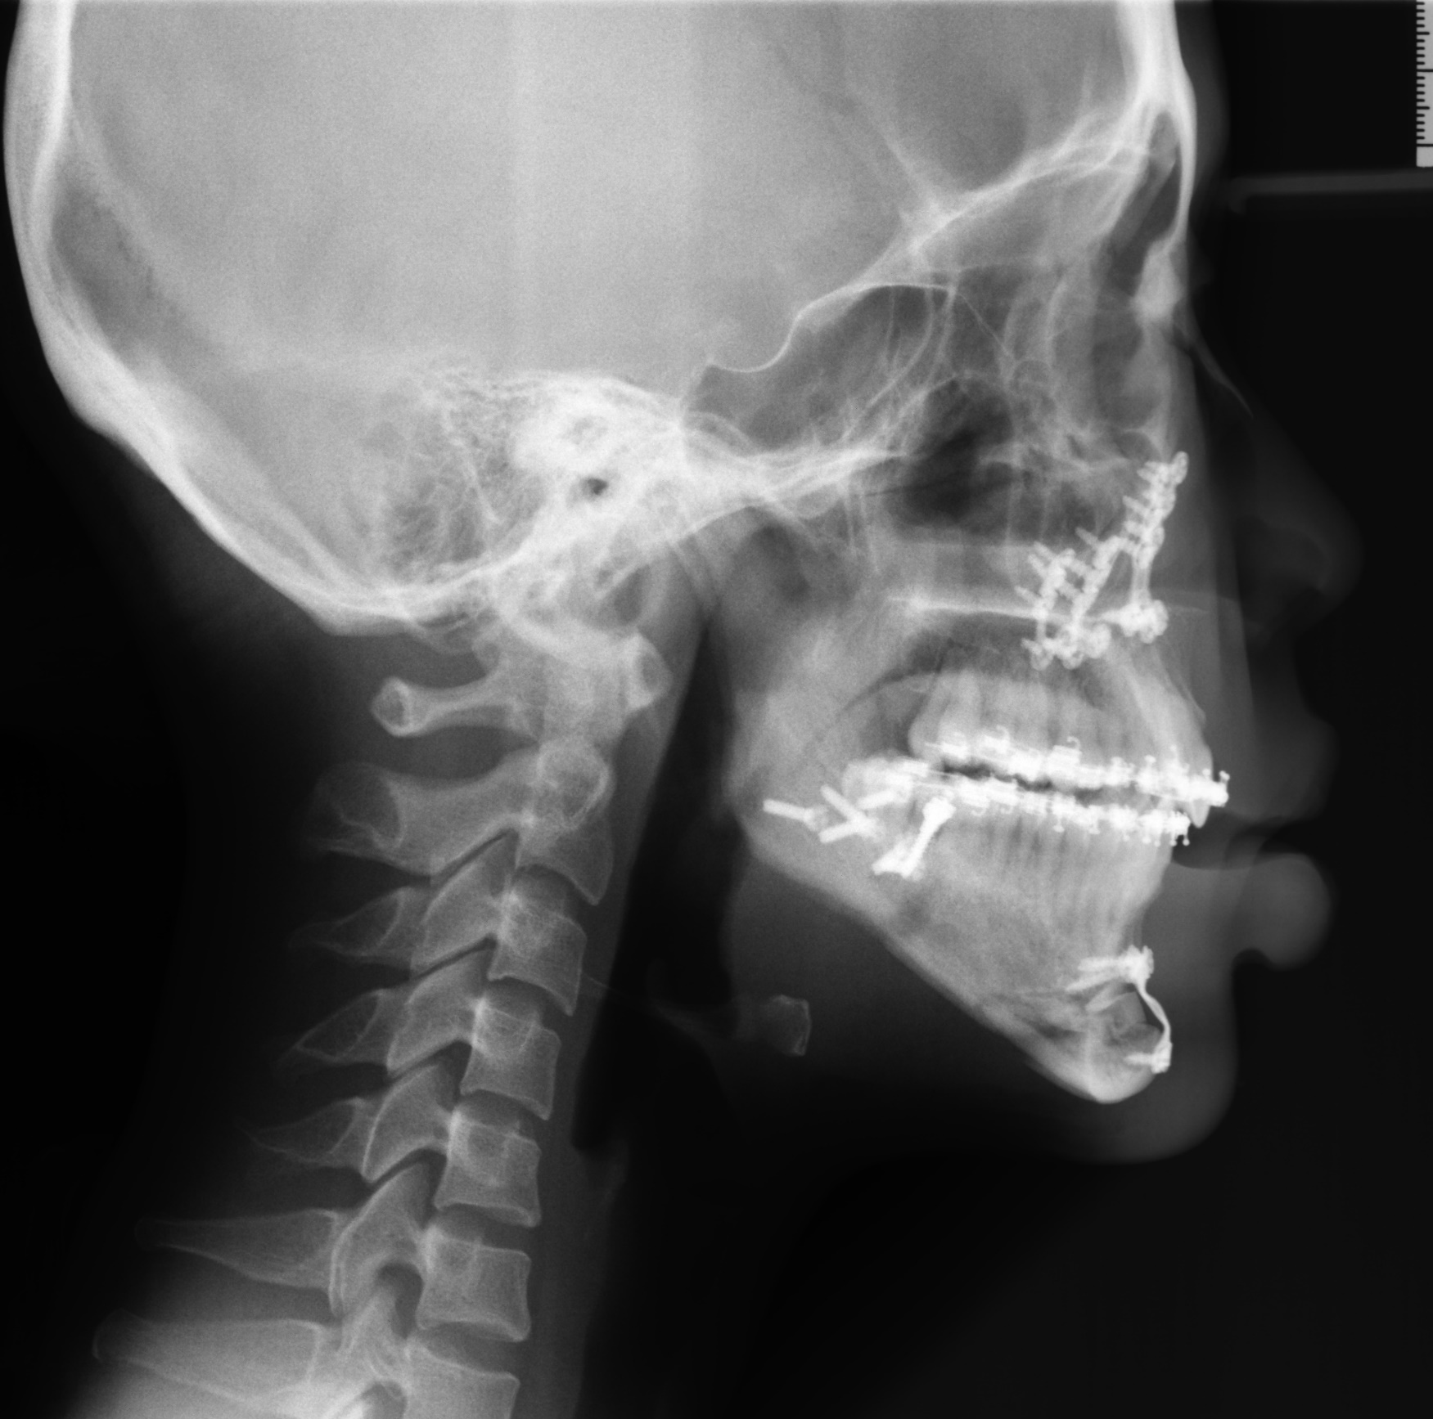

其他佐證資料：（可依需求置放，注意勿出現機構或考生資料）
- Adult malocclusion with multidisciplinary treatment

